

**CHICAGO CITY, ILLONOIS**

**Violence Reduction Chicago City**



**December 8, 2024**

**university of north texas**

**Denton, TX 76201**

**Instructor Dr. Denise Philpot**

Azhan Saleem

CPD Analytics: Crime Patterns and Socioeconomic Factors in Chicago

Introduction 5

Dataset 5

Research questions 6

Introduction 6

Effect of time of day on crime severity 7

Distribution of crime rates across different income levels 8

Analyze interventions or strategies used to address crime in high-crime districts. 9

Factors influencing fatal outcomes in gun-involved incidents 10

Predicting and Preventing Gun Violence 11

Summary 19

Chapter 3 Methodology 20

3.1 Research Design 21

3.2 Data Collection Methods 21

3.3 Dataset Description 22

3.3.1. Chicago Police Department Dataset: 22

3.3.2. Census Data: 23

3.4 Data Preprocessing 24

3.4.1 Handling Missing Values: 24

3.4.2 Removing Duplicates 24

3.4.3 Data Merging 25

3.4.4. Creation of New Variables 25

3.4.5. Data Transformation 26

3.4.6. Data Filtering and Sub setting 26

3.4.7. Statistical Operations 27

3.4.8. Geospatial Analysis 27

3.4.9. Visualization Techniques 28

3.5. Exploratory Data Analysis, EDA 28

3.5.1 Descriptive Statistics: 28

3.5.2 Visualizations: 29

3.5.3 Correlations: 30

3.5.4 Demographic Analysis: 31

3.6 Ethical Considerations 31

3.7 Reliability and Validation 32

Chapter 4 Results and Discussion 33

4.1 Introduction to Results and Discussion 33

4.2 Research Question 1: Impact of Day on Crime Frequency and Severity 34

4.2.1 Data Selection and Preparation 34

4.2.2 Analysis of Crime Frequency by Day 35

4.2.3 Analysis of Crime Severity by Day 37

4.2.4 Community Impact and Crime Disparities 39

4.2.5 Crime Incident Distribution by Community and Day 40

4.2.6 Crime Frequency by Time of Day 41

4.2.7 Crime Type and Community Area Distribution 43

4.2.8 Heatmap Analysis of Community Area and Incident Types 44

4.3 Research Question 2: Distribution of Crime Rates and Types by Income Levels 46

4.3.1 Data Selection and Preparation 46

4.3.2 Crime Type Distribution by Income Levels 47

4.3.3 Crime Type Analysis by Income Bracket 49

4.3.4 Crime Distribution by Poverty Levels 51

4.3.5 Crime Distribution by Education Levels 52

4.3.6 Crime Distribution by Unemployment Levels 55

4.3.7 Geospatial Analysis of Crime and Income Levels 57

4.4 Research Question 3: Crime Distribution in Top Five High-Crime Districts 59

4.4.1 Data Selection and Preparation 59

4.4.2 Identifying the Top Five High-Crime Districts 60

4.4.3 Crime Type Analysis in the Top Five Districts 61

4.4.4 Crime Incident Distribution by Hour and Day of the Week 62

4.4.5 Percentage of Severe Crimes by District 62

4.4.6 Victim Age Distribution in Top Five Districts 64

4.4.7 Gender and Race Distribution of Crime Victims by District 65

4.4.8 Geospatial Analysis of Crime in Top Five High-Crime Districts 67

4.5 RQ 4: Likelihood of fatality with the presence of the Gun 68

4.5.1 Data Selection and Preparation 68

4.5.2 Descriptive Statistics and Likelihood of Fatality in Gun-Related Incidents 69

4.5.3 Contingency Table and Chi-Square Test for Gun Presence and Fatality 70

4.5.4 Logistic Regression Model for Predicting Fatality in Gun-Related Incidents 72

Chapter 5: Conclusion and Recommendations 74

5.1 Summary of Key Findings 74

5.2 Interpretation of Results 75

5.2.1 Crime Rates and Distribution 75

5.2.2 Impact of Time and Day on Crime 75

5.2.3 Severity of Crimes Across Districts 76

5.2.4 Gun Presence and Fatality 76

5.3 Recommendations for Stakeholders 77

5.3.1 Policy Recommendations for Crime Prevention 77

5.3.2 Strategies to Reduce Gun-Related Fatalities 77

5.3.3 Resource Allocation in High-Crime Areas 78

5.3.4 Enhancing Public Awareness and Support 78

5.4 Future Research Directions 78

References 80

# Introduction

In the United States (U.S.) people who are victimized by guns are 13 times more than any other high-income country. According to statistics from 2015 to 2022 around 19 thousand people are victimized by gunshots. Victims are either killed or wounded. According to in U.S. 59% of adults have said either their relative or someone whom they have experienced gun violence and 41% among them are victims of trauma due to that tragedy. This disease has infected everyone irrespective of everything such as Black, White, Latin, and any other (Everytown for Gun Safety Support Fund, 2024).

Gun violence has emerged as a global problem in different communities causing catastrophic damage to the well-being of humans and costing lives. With the analysis of victim stories here, we aim to highlight and encounter challenges they face. Provide them assistance which they require and possible intervention for reducing the occurrence of gun violence.

These acts of violence can be reduced by identifying the root causes behind these acts. The factors that are contributing to these acts of violence are poverty, unemployment, untreated mental illness, gun culture, and easy availability of guns and Police practices.

# Dataset

The Chicago Police Department (CPD) has gathered this data daily. In this dataset, each row represents the victimization of an individual due to homicide or non-fatal shooting. In this dataset each row does not represent a unique victim; in case one is victimized multiple times there will be multiple rows for each of those districts. The data is recorded from 1991 to the present and the non-fatal shooting data from 2010 to the present. Here I will take data from 2017 to the present. Apart from this data, we will get data related to some socioeconomic issues such as income level from the census. In this data we will create two new features, one is income level from data collected on income and the day (Morning, Afternoon, Evening, and Night) which will be created from hours (*Violence Reduction - Victims of Homicides and Non-Fatal Shootings | City of Chicago | Data Portal*, 2024).

The dataset also has variables related to administrative or political boundaries that are subject to changes. The dataset has variables STREET_OUTREACH_ORGANIZATION, WARD, DISTRICT, BEAT, STATE_HOUSE_DISTRICT, STATE_SENATE_DISTRICT. These variables are referred to according to the current geographic boundaries of November 1st, 2021. In the last, there are 38 columns and 61000 observations

# Research questions

1. What impact does the day have on the frequency and severity of crimes and how do these disparities have an impact on communities?
2. What is the distribution of crime rates and types in different levels of income and what policies are beneficial in addressing these disparities effectively?
3. What are the most common crimes occurring in districts, compare the frequency of the crimes in the top five high-crime districts.
4. What is the likelihood of fatality in the incident with the presence of the Gun?

# Introduction

Gun violence has risen to be a very alarming issue in various cities for instance Chicago city is a severe threat to lives. Across the same period, 19,000 gun-related victims have been documented and the gun victimization rate in the US is 13 times higher than in other high-income countries. This issue cuts across the racial and socioeconomic structure of people with the blacks, Latin, and indigenous people to the white people. This concept proposal seeks to address explainable factors behind gun violence in Chicago and the effects of these violent acts on society. Our goal for this analysis is to raise awareness of specific issues such as poverty, unemployment, untreated mental illness, gun culture, and police practices from the CPD as well as data from the censuses that have led to the Crisis. The analysis of such cases will enable us to understand the difficulties encountered by the victims and find ways to minimize the usage of firearms. Thus, by dealing with the causes of these actions and concerning significant features including income differences, geographical distribution of criminal acts, and the local specialist organizations’ participation, this work will help improve the understanding of the increasing safety measures in Chicago.

# Effect of time of day on crime severity

The study compares the rate and severity of injured patients by assault type, weekday, month, and weekday-by-month interactions. Concerning the findings, from the US NES data, the researchers defined patterns, for instance, elevated risk on the weekends, especially at night and during summer. These patterns are caused to show how the days of the week and seasons of the year are associated with an increase in violent occurrences. With regards to logistical applications in the study, the research provides useful recommendations for public health and safety in large cities; revealing that potential solutions such as tightened police patrols or preventive efforts to combat crime might be beneficially implemented during specified risky periods including weekends and summer. Furthermore, Health care systems could also use this information to anticipate high incidences of assault-related ED visits during this period. However, the study is deficient in the sense that only ED data are used and non-reported assaults or other incidents that did not lead to the ED visit may not be considered, which could result in underplay of the situation in a community. Overall, the study enhances the time-wise understanding of assault-associated injury as the literature lacks such fine-grained temporal analysis but the findings are confined to the isolation of demographic variables and level of severity and these should be extended in future research by including sociocultural characteristics and data other than emergency department records such as police files (Khurana, 2022).

# Distribution of crime rates across different income levels

The paper examines how temperature fluctuations affect crime in high and low-poverty urban communities. Both authors emphasize the worsening of crime with heat especially in the poorer neighborhoods through the interaction of environmental and social stressors. The study, with a dataset of crime reports and temperature data, finds that violent crime tends to increase and become more frequent only in high-poverty districts during hot weather, while affluent neighbors report more property crimes. This study is based on the conceptual framework of environmental criminology according to which environmental conditions like heat increase the crime rate, the present research incorporates the new aspects of poverty influencing the reaction to environmental stress. The findings suggest that policymakers and city planners should address specific problems, such as making facilities for the poor to cool their homes in high crime-prone areas during emergencies. However, the statistical study adopts temperature as the key variable working against the analysis of numerous socio-economic factors contributing to differential crime rates such as unemployment or housing conditions, limiting the study’s implication. The findings above suggest the directions for future research are the inclusion of further variables and investigation into a more in-depth relationship between climate context and crime over time. Overall, the work makes a significant contribution to the literature on criminology concerning how environmental factors affect the spatial concentration of crimes in cities thus pointing out measures towards developing safer cities through efficient use of resources for fighting crime in cities such as Chicago (Heilmann, 2021).

# Analyze interventions or strategies used to address crime in high-crime districts.

The study gives a systematic view of different assessments of focused policing procedures in violent crime areas to understand the results of these interventions. In this regard, they opine that hot spot policing may reduce the crime rate since the efforts and crackdown are brought to bear on the areas that are most affected by the worst crimes. This review is supported by theories in environmental criminology stating that crime is not evenly distributed but is dispersed, according to socio-economic and environmental features in certain locations. However, it should be noted that the transformation of the policing strategies from the traditional methods to the detailed interventions based on approaches to crime changes should be highlighted. The review shows contemporary trends in policing and finds that police administration is increasingly using data to guide its operation. From a methodological point of view, the review integrates the outcomes of numerous works and shows that a consensus has emerged about hot spot policing’s ability to reduce crime rates, especially violent and property crimes. However, some concerns have been presented by the authors such as risks for communities, which are inclusive of impacts such as negative perception by the public and ethical concern of focalization of policing. Thus, they encourage the conduct of more studies to determine other long-term effects and an attempt to understand if doing hot spot policing in conjugation with other community policing activities is effective (Braga, 2019).

# Factors influencing fatal outcomes in gun-involved incidents

This research explores the Influence of Elements of the Social and Physical Environment on Neighborhood Gun Crime and looks at the relationship between the social and physical environment and gun crime within neighborhoods. The theory presented is grounded in criminology with special references to routine activity theory and environmental criminology that gives much importance to opportunity in crime. The methodology of how environmental factors have been considered in the study of crime has also changed over time, but people decided that the characteristics of the neighborhood play a significant role in crime. The authors outline the latest focus of research trends, and it can be observed that scholars pay considerable attention to the socio-spatial aspects of gun crime. In terms of approach, the study uses a historical review of published materials where the researcher systematically identifies and categorizes studies that report on factors that can lead to gun violence. The previously mentioned major studies reveal social disorganization was also strongly associated with the level of gun crime and that rate characteristics, comprising empty buildings, played an important role in the crime rate. The author determines that there are practical implications and if special efforts are made to address the relevant environmental factors gun violence can be prevented. Issues include a lack of robust data, the need for qualitative and quantitative analysis, and an interaction of thoughts across disciplines (Thomas, 2021).

# Predicting and Preventing Gun Violence

According to the research which is done on the performance of the READI (Rapid Employment and Development Initiative) Chicago program, which has been developed to reduce the probability of gun violence incidents in people who are close quarters to similar incidences. The theoretical foundation for the strategy derives from concepts of behavioral economics and social psychology and mainly involves applying cognitive behavioral therapeutic techniques to change the behaviors of high-risk individuals. The study provides a historical approach to gun violence in Chicago and points out the fact that earlier intervention measures were somewhat effective. The authors describe contemporary practices, focusing on the fact that the key approaches to creating successful scopes for disabled people are the combinations of therapy, employment as well as social services that are being developed progressively. Regarding the research design, this will employ an RCT to assess READI Chicago and obtain data on violent crime and gun violence among the participants of the program. According to the program’s major findings, there has been a reduction in participants’ gun violence compared to a non-program control group. Concerning practical applications, the authors insist on enlarging such programs because the findings point to positive effects concerning the safety of communities. But old issues persist; for instance, implementation costs are high and there is the issue of sustainability. Overall, this article adds to the body of knowledge of effective practice mechanisms to help Chicago reduce the incidence of violence, especially the use of guns (Bhatt, 2024).

In measuring the effects of precision policing on gun violence, the paper explores “gang takedowns” with special reference to New York City. The study has theoretical importance by adopting the principle of focused deterrence, according to which crime can be contained by targeting the offenders. To offer historical background, the authors reveal the organizational transformations of police work, while precision policing appeared as a contemporary model associated with the fight against organized criminals and gun violence. The researchers relied on a quasi-experimental research design and relied on police data and statistical analysis on the effects of those interventions. However, the major conclusions indicate that gang operations had an impact on the minimization of gun violence in those regions and, thus, the assumption here was that targeting high-risk individuals and teams would prove effective. Issues like the possible displacement of crime and the importance of the ethical aspects of focused deterrence are elaborated. The study also argues that there is practical relevance to carrying out more research on how to improve such policing approaches as well as discharge any undesirable consequences. The study therefore advocates for policy improvement in precision policing to guarantee ideal and community-based criminal prevention measures (Chalfin, 2021).

The authors conduct a statistical analysis of urban demolitions related to problems of firearm violence and drug crime to investigate changes in crime rates. The theories applied in the context of the research are derived from an area of environmental criminology that postulates that changes in the environmental environment can influence the amount of crime. Derelict buildings that act as breeding grounds for anti-social behavior are then earmarked for destruction to rid the neighborhood of this blight and curb related crime. Previous urban renewal interventions have sought to reactivate cities, but this analysis directly targets demolition Violence, and Drug-Related Crimes. Fixed effect models were employed to compare the findings before and after the demolition of buildings from several urban neighborhoods in a quasi-experiment research study by the authors. However, the fundamental facts reveal the general overall decrease in gun violence and drug crime, thus providing evidence that the qualitative alteration in the physical texture of urban space is a realistic crime control strategy. These studies have implications for real life especially for metro-urban centers such as Chicago where violence is still a pivotal concern. The same types of progressive demolition endeavors would be useful in mitigating firearm violence and drug criminal activity in high-risk areas (Jay, 2019).

The effective evaluation of the Safe Passage Program in Chicago is the subject of the study that was initiated to improve safety at schools by increasing children's supervision in unsafe areas. Before analyzing the results of the program, the authors use difference-in-differences and state-of-the-art matching techniques for crime data collected before and after the program. By their records, they prove that there is crime reduction, especially violent ones, in the Safe Passage areas. The research also offers a strong theoretical argument for the so-called ‘broken windows theory’ - according to which much crime can be prevented with small-scale signs or symbols of law and order. The residents are engaged to own and be a part of the transformation since they are activated as monitors of the program. The study also contributes to the existing debates on urban safety. Despite such limitations as displacement effects and long-term sustainability, the authors provide evidence to support their claim that Safe Passage and similar programs can become a model to be followed by other cities. All in all, it is revealed that Community-based intervention can effectively decrease violence in urban areas to the stakeholders who are aware of the similar context (McMillen, 2019).

From the study, a survivor is shown to face a lot of practical impairments, suffering from physical, emotional, as well as social effects of gun violence. Medical requirements, psychological counseling, resettlement, etc. are required on an ongoing basis. ESP was mainly highlighted in feelings of loneliness and exclusion; it would take integrated community services for participants to return to normalcy and wholesale reintegration into society. The results show the lack of care for gun violence survivors as a clear gap which means that healthcare needs to change a lot after discharge. They will include not only doctor visits but also counseling sessions as well as social support services since the above clients are complicated in one way or another. Thus, the present study may contribute to the analysis of the experiences of those who faced gun violence providing a variety of potential recommendations for politicians and practitioners who work to decrease violence rates together with improving the quality of life of the shot victims. This paper locates itself within a large existing knowledge base about violence prevention by arguing that intervention following a shooting would be helpful; such post-tension would address the effects of gun violence on people and communities. Therefore, this current study advocates for a complex mimic in sighing the complexity of the issue of gun violence and its aftermath in the urban settings of Chicago (Patton, 2019).

Perhaps explaining that through crime statistics before, during, and after the time of major sports events, the authors show that the crime rate is significantly lower during such events and among the neighboring areas. They were in a position to associate this decrease with security enhancement, policemen patrols, and people’s encampments in areas that can easily be guarded, which in turn discourages any criminal-like conduct. This paper argues that any form of entertainment such as sports games can act as an unconventional tool in discouraging the occurrence of crime as it clears the chances of the occurrence of the acts in the nearby areas. Also, the authors point out that this strategy helps to keep people away from corrupt places and gives some measure of reprieve to specific precincts that are likely to have higher crime rates. Therefore, this study indicates that policing efforts in areas experiencing violence could be supported by other approaches of crime prevention like planning and hosting community or entertainment-related activities. Chicago and all other cities with massive population concerns should embrace this research as a means of understanding how or else group assembling can fuel crime rather than prevent it. The conclusions expand on the issue of urban violence by arguing that large-scale entertainment events are a feasible form of crime reduction strategies beyond conventional crime policies. It is therefore in line with continuing initiatives to prevent violent crime and violence in towns and cities and to promote innovative approaches to reducing violence (Copus, 2019).

The authors explain that injustice factors like racism and limited economic opportunities have the role of pro-actively maintaining violent patterns. Through examining programs undertaken by local people, this research thus provides real-life evidence that community-organized strategies like neighborhood watch, and violence eradication programs are solutions to these systemic adversities. The article also reviews the use of technology, or more precisely HCI, in these drives. Here they give examples of how technology is used to facilitate the voices of the impacted groups in addition to strengthening the networks of such groups. This bottom-up Violence prevention model, which is backed up by technology, is different from the traditional policing approach that is normally top-down. When it comes to Chicago’s continuous fight against urban violence, the focus of the study on local approaches to the problem relates to the wider discourses of community resilience against violence. The authors present a very persuasive case for technology solutions when envisioning community-centered violence reduction as a means of addressing the forms of structural oppression that hinder social change. The findings of this research are useful in understanding how community intervention strategies can lead to safer spaces as well as total elimination of the incidence of violence with the goal of violence prevention in Chicago in mind, therefore, this work is helpful (Dickinson, 2021).

The authors note that these youths are violated and highlight that any violence affects them in terms of mental health and development. Since formative research methods are used, the study features the participants’ perspectives on violence and the strategies they build. The last analyzed concept is social networks: positive connections within families and communities help build a resilient environment. Mentors, educators, and peers all played a big role for the participants in helping them deal with the environments as stated by the participants. Further, the study aims to show that it is possible to prevent the effects of violence through functioning social capital that is evident in most communities and through putting up protective environment-based interventions. The authors also state that prevention and elimination of violence are not limited to addressing immediate and tangible dangers; in addition, they should presuppose changes that would help young people become active and influence societal processes. In doing so, the study is useful to policymakers and practitioners interested in violent crime prevention and community violence reduction to appreciate the underlying causes and promote community resilience. In aggregate, this research effort adds to the literature focusing on enhanced understanding of the youths residing in urban settings; therefore, outlines directions for creating programs that can potentially foster increased resilience, coupled with the decreased incidence of violent tendencies (McCrea, 2019).

The authors examined the effects of lockdown and social distancing on crime by focusing on several different categories of crimes including burglaries, assaults, as well as narcotics. The authors believe that this is due to people’s increased presence at home, which was accompanied by a decrease in burglaries. Nevertheless, some violent crimes, for example, assault, have remained almost the same during the pandemic, and worse in areas that were already notorious for violence before the outbreak of the pandemic. This type of research is very significant to the task of reducing violence particularly in Chicago because ‘” One Size Fits All is’ not preferred where people live. According to the authors, the single approach does not seem to work since different neighborhoods with different socio-economic types show different changes in crime. Understanding these processes is indispensable for effective crime prevention as the interventions that are aimed at the main sources of criminal activity in the high-risk zones are designed by practitioners. The study also contributes to insights into how external factors, like a pandemic, affect crime in cities and disrupt ongoing crime prevention measures, so the study offers a useful roadmap for subsequent studies concerning violence prevention (Campedelli, 2020).

The study examines how various environmental features or indices, particularly air pollution, impact criminal rates in employing cities. In this map, the authors use micro geographic data in Chicago to determine how air quality influences different types of crimes and establish that inflation in pollution significantly leads to increased crime levels. The authors use sound statistical tools to decompose the impact of air pollution with the impact of other factors that can affect crime rates including the level of income and population density. According to the study, the level of pollution of the atmospheric air used as a criterion significantly corresponds to the overall rate of crime in a specific area and the rate of violent crimes. This paper establishes that the concern about crime prevention should involve public health, hence the need to address environmental issues affecting most urban areas. However, the lessons in this research are not insignificant for policymakers who seek to minimize violence in other cities, especially Chicago. Using environmental factors as an antidote to explain criminal activity, the study promotes the integration of air quality into schemes that aim at controlling violence. In essence, this research adds great value to the global discourse on crime and environmental health within urban environments thus creating room for subsequent research that seeks to unpack the radicals of violence in metropolitan areas (Herrnstadt, 2021)

The study explains in detail how newspapers use specific discursive measures that reinforce negative attitudes towards the neighborhoods in question as dangerous and vulnerable. Indeed, this framing often requires the use of what can be described as over-the-top language and giving it a rather one-sided look and that is where the worst of it appears to stem from, as it further stigmatizes these areas, which seem to already be struggling enough as it is. The interpretive lens utilized in the present article included media studies and territorial stigmatization, which will elaborate in the analysis as the principle for examining the generality of discursive media influence on community dynamics and perceptions of The Real Estate Market has changed with time and stigmatization is not the exception, the current perception of some sections of the neighborhoods as ‘no go areas’ can be attributed to such historic occurrences. Analyzing the negative media imagery and the resulting communal attitudes in Schwarz’s research offers theoretical approaches toward reducing violence in Chicago, which need to be supplemented with the identification and elimination of discursive stigmatization. The results imply that the modifications for the media practices may be identified as one of the key treatments for improving community relations and enhancing policy outcomes (Schwarze, 2022).

# Summary

All the articles put together focus on issues related to crime control and the causes of violence with special reference to cities such as Chicago. Research and development’s findings presented in READI Chicago evidence effective reduction of gun violence following the experiments while identifying and implementing precise police tactics, such as gang takedowns, are effective in gun violence reduction. A reliable method of instability control, known as hot spot policing of a small area is identified and recommended. Indeed, involving citizens throughout all schemes like Chicago’s Safe Passage tends to indicate that grassroots movements matter to violence abatement and that impoverished neighborhoods for instance should equip their inhabitants with necessary strength reserves. Some changes in crime rates during the COVID-19 pandemic are observable, but these effects might be different for various areas; other research on crime rates in cities during hot weather and periods of increased air pollution proved that environmental conditions affect criminal activity. Furthermore, existing research on violence reporting by media is also analyzed, which reveals the territorial branding of certain districts. In addition to this, entertainment; for example, sports events are also used to indicate that it has an influencing factor of directing attention and reducing crime during certain periods. The experiences of patients who are shot and require care post-discharge show that the patients require better support. Last, the neighborhoods’ physical and social setup as well as schedules of assault injuries by the weekdays are additional valuable information about crime and violence.

Chapter 3 Methodology

## 3.1 Research Design

Quantitative research design is used in this study to analyze gun violence data in the United States with emphasis on incidents captured in Chicago. It is based upon a systematic collecting and analyzing of numerical data to help identify patterns and relationships concerning gun violence. (Gottfredson, M. R., & Hirschi, T., 1990) The research seeks to examine the effect of different factors such as presence or absence of firearms on victim demographics, and underlying crime distribution across districts on the likelihood of fatal outcome. The research design provides an opportunity to investigate all the intricacies surrounding the issue of gun violence, in order to contribute to policymakers and community groups who seek to prevent crime. (Lauritsen, J. L., & Rezey, M. L., 2013)

## 3.2 Data Collection Methods

For this study data was collected from a number of reputable sources for accuracy and for completeness. The primary dataset “Violence_Reduction_-_Victims_of_Homicides_and_Non-Fatal_Shootings_20241008.csv” used is the Chicago Police Department's records on reported incidents of gun violence, which includes detailed information on the nature of each incident, location, time, and involved individuals and we accessed the dataset from ‘https: Violence Reduction: Victims of Homicides and Non-Faith Related (data.cityofchicago.org)

Additional data “Census_Data_-_Selected_socioeconomic_indicators_in_Chicago__2008___2012.csv” was collected from U.S. Census Bureau (<https://resources> including (<https://catalog.data.gov/dataset/census-data-selected-socioeconomic-indicators-in-chicago-2008-2012>) To provide context on demographic variables such as income levels, population density, other socio-economic indicators. The collection techniques were such that they accessed publicly available datasets, making sure the data are reliable. Data from various sources was cleaned and validated in order to handle any inconsistencies or value missing from the datasets, prior to analysis.

## 3.3 Dataset Description

The analysis utilizes two primary datasets: for the Chicago Police Department Dataset and the Census Data.

3.3.1. Chicago Police Department Dataset:

The details of gun violence incidents are reported by this Chicago dataset. Key variables included in the dataset are:

* ZIP_CODE: The ZIP code in which the incident took place.
* WARD: The ward that the incident was reported in.
* COMMUNITY_AREA: The area of the incident position in the community.
* MONTH: The name of the month that the incident occurred in.
* DAY_OF_WEEK: The day of the week of the incident.
* HOUR: The time of the incident.
* LOCATION_DESCRIPTION: The location type described (e.g., 'apartment', 'street' or 'restaurant').
* LATITUDE and LONGITUDE: Location of incident.
* LOCATION: The geographical location of the incident represented in a POINT.

The dataset consists of a total of 38 variables with data from 2001 up to now for a variety of gun violence cases. Thousands of reported incidents fit into the sample size and are subject to comprehensive statistical analysis.

3.3.2. Census Data:

Released by the city of Chicago, this dataset includes socioeconomic indicators for each community area between 2008 and 2012. Key variables in the dataset include:

* Community Area Number: A way of distinguishing each community area with a unique identifier.
* COMMUNITY AREA NAME: The name of the community area.
* PERCENT HOUSING CROWDED: Percent occupied housing units with one or more persons per room.
* PERCENT HOUSEHOLDS BELOW POVERTY: The federal poverty line percentage of households living below the federal poverty line.
* PERCENT AGED 16+ UNEMPLOYED: It is a percentage of individuals over 16 years who are unemployed.
* PERCENT AGED 25+ WITHOUT HIGH SCHOOL DIPLOMA: The percentage of individuals over 25 that do not have a high school degree.
* PERCENT AGED UNDER 18 OR OVER 64: The ability to determine how much is under 18 or over 64 percent.
* PER CAPITA INCOME: Approximately how much did the community area have for the average income per person.
* HARDSHIP INDEX: A socioeconomic indicator score representing community hardship.

The variables in this dataset are vital socioeconomic data which can help us to understand the context behind gun violence, each variable offering information about the different community areas.

3.4 Data Preprocessing

### 3.4.1 Handling Missing Values:

We found several missing values across multiple columns of the dataset that needed initial examination. To address this, we employed a two-step approach:

* Identification: Statistics like ‘isnull()’ , ‘sum()’ were being used to quantify the missing values in each column.
* Imputation/Removal: We chose to: fill in missing values with mean, median, mode in case of missingness or remove rows where crucial info was missing based on the number of missing values. For example, suppose `VICTIMIZATION_PRIMARY` was a critical variable (which needed to be understood), but had missing values, then we had to remove those rows since the integrity of the analysis is maintained.

3.4.2 Removing Duplicates:

Using duplicated () function we did a check for duplicate entries and then dropped any duplicate rows. This was important to ensure a reliable dataset without repetition of incidents based on the distinct type.

3.4.3 Data Merging

* So, we merged the crime dataset (df_violence) with the socioeconomic dataset (defenses) by joining the common key COMMUNITY_AREA. This allowed a combined dataset linking crime incidents to demographic and economic information about the respective community areas.
* Cross-Referencing Data: Community area codes and names were cross referenced during the merging process to correctly associate crime data with their respective socioeconomic indicators.

### 3.4.4. Creation of New Variables

* Income Levels: On the Per Capita Income column, another new categorical variable, Income Level, was created. Compared, income levels were grouped into brackets (such as low, middle, high) according to which the analysis was made.
* Poverty Status: The percentage of households below the poverty line was also used to create another categorical variable designating poverty levels (high poverty, medium poverty, low poverty).
* FATALITY_STATUS: A binary indicator variable was created in Victimization primary, indicating whether an incident was fatal (coded as 1) or non-fatal (coded as 0).
* GUN_PRESENT: A new binary column, GUN_PRESENT, was created for the GUNSHOT_INJURY_I column where cases involving a gun were marked 1 and all others marked 0.

### 3.4.5. Data Transformation

* Standardization: To ensure that differences in size of population for the different community areas and different economic conditions do not hinder comparing the variables like per capita income and poverty rates variables, they were standardized.
* Crime Types: They were then grouped into broader categories such as violent (e.g. homicide, battery) and property (e.g. robbery) to facilitate broad analysis. (Rosenfeld, R., 2000)
* Time Variables: The HOUR column was extracted from the timestamp of the incidents in order to analyze crime by time of day and time specific patterns could be examined (e.g. crime spikes at night).

### 3.4.6. Data Filtering and Sub setting

* Filtering for Gun Incidents: A subset of the dataset was created to focus specifically on incidents where a gun was present using the GUN_PRESENT column.
* Top Crime Districts: Districts were ranked based on the total number of incidents, and subsets of data were created for the top five high-crime districts to focus the analysis on the most affected areas.

### 3.4.7. Statistical Operations

Descriptive Statistics: Before we carry out further analysis, we smize the data by calculating key statistics (mean, median, standard deviation) on variables like crime counts, income levels and poverty rates.

Contingency Tables: To see how gun involvement is related to fatal outcome a contingency table was made, and a Chi square test was performed to check for statistical significance.

Logistic Regression: In order to check how the gun presence affect the probability on fatality, a logistic regression model was built whereby FATALITY_STATUS is the dependent variable and GUN_PRESENT is the independent variable.

### 3.4.8. Geospatial Analysis

Mapping Crime Incidents: A geospatial map was produced of the top five high crime districts, which shows the propagation of various crime types in this dataset's latitude and longitude coordinates. Our maps were made with libraries such as Plots to show where crimes were concentrated in Chicago. (Block, R. ,2015)

### 3.4.9. Visualization Techniques

Various charts and graphs were used throughout the analysis, including:

* Visualization of crime types distributed by different districts and socioeconomic levels can be made using bar charts.
* Visualization of the temporal distribution of crimes by hour of day and day of the week in high crime districts in form of heatmaps.
* But instead of using pie charts to represent the proportions of fatal and nonfatal gun related incidents.
* Visualize the geospatial distribution of crimes across districts, and community areas in scatter maps.

This preprocessing step was crucial, as a bad dataset would prevent us for doing in-depth statistical analysis and visualization.

## 3.5. Exploratory Data Analysis, EDA

### 3.5.1 Descriptive Statistics:

Descriptive statistics basic were generated to summarize the dataset with measures of central tendency (mean, median) and measures of dispersion (standard deviation and range). This gave us a foundation of the data distribution, and areas that we’d like to explore further.

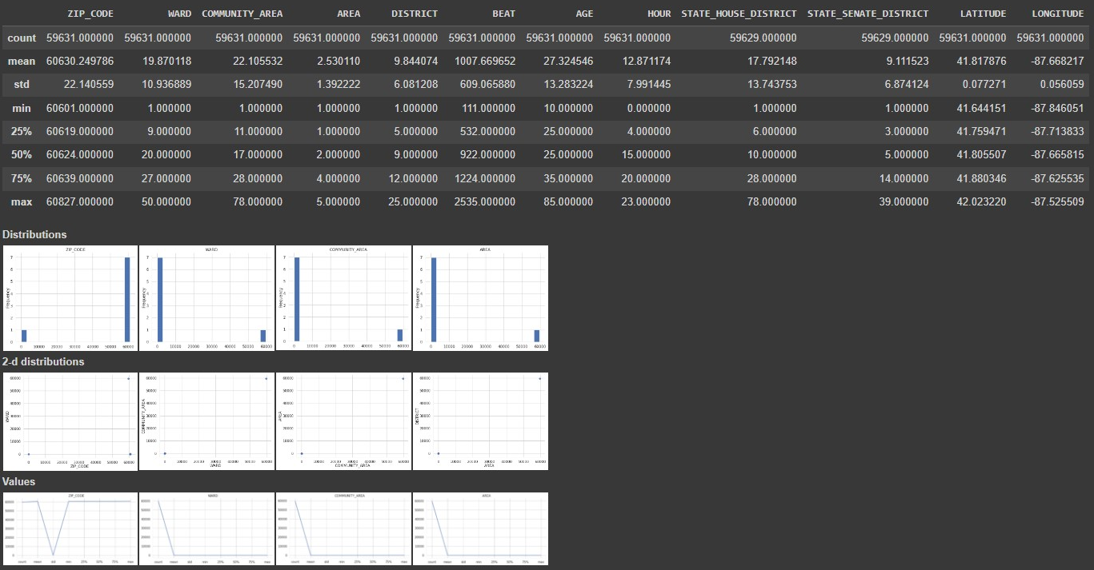**Fig. Descriptive statistics**

### 3.5.2 Visualizations:

Distribution of Crimes: We visualized the frequency of different crime types using histograms and bar plots and found where the most common crime types were in the dataset.

Heatmaps: The distribution of crimes by hour and day of the week was illustrated in heatmaps that allowed us to find temporal patterns in criminal activity.

Fig. distribution of crime types

### 3.5.3 Correlations:

We performed correlation analyses on numerical variables to identify relationships to understand which factors may have influenced crime rates.

3.5.4 Demographic Analysis:

To do this we looked at bar plots that showed us the demographic distribution of victims by age, gender, and race of a victim and what we saw is that there are patterns as far as victimization of different demographics. (Block, R. ,2015) The ability to understand the more general implications of crime in the analyzed districts was crucial.

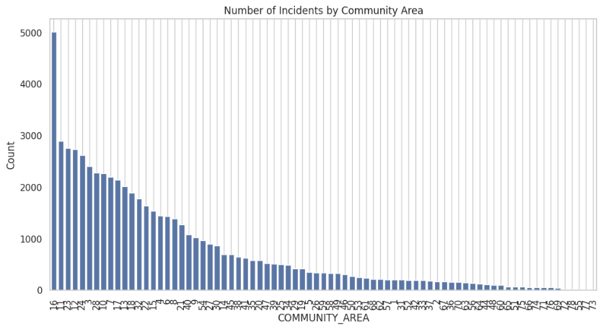

Fig. Crime by demographics

Having conducted proper data preprocessing and EDA before our analysis, we made sure the data we had was solid to base our findings from the dataset regarding gun violence and the population it affects.

## 3.6 Ethical Considerations

This research on gun violence was guided by ethical considerations. Key aspects included:

Data Privacy

Anonymization: The dataset was stripped of all the personal identifiers to protect identity of people.

Secure Storage: It ensured secure data storage, and only authorized personnel access.

Informed Consent

Public Data Use: The data was publicly available and thus explicit informed consent was imbedded in the research methodology. That maintained transparency of data use.

Community Impact

Sensitivity to Communities: It considered how the community being affected could be and sought to present findings responsibly.

Avoiding Harm: To reduce the damage and report findings that could engender good action rather than stigmatic associations among affected individuals or community. (Gottfredson, M. R., & Hirschi, T., 1990)

## 3.7 Reliability and Validation

To ensure the reliability and validity of the findings, several strategies were employed:

Data Quality Checks

Consistency Checks: They confirmed that data sufficiency was attained by verifying for disparities as well as implausible values.

Cross-Verification: Comparisons were made on data from multiple sources.

Cross-Validation Techniques

Dataset Splitting: Models were validated independently using the dataset divided into a training and testing subset.

Bootstrapping: The stability and variability of the findings were assessed by this technique.

Statistical Techniques

Statistical Testing: Significant patterns were confirmed using tests such as t tests and chi square tests.

Effect Size Calculation: The practical significance of the findings was given context by effect sizes.

Such measures were in place to make sure that the research findings were ethical and credible.

# Chapter 4 Results and Discussion

## 4.1 Introduction to Results and Discussion

To address research questions, the results and discussion chapter analyzes the data collected and the insights gained, so that the work clears the air and creates the premise on which subsequent literature review will extend. The purpose of this chapter is to investigate the distribution and severity of crime by socioeconomic dimensions (income, poverty and educational attainment) as well as of the temporal patterns of criminality and the effect of firearms in fatal incidents. The authors structure each section to present key findings, followed by an interpretation of results, to give an overall understanding of the underlying patterns, correlations and potential implications for crime prevention and policy development. This chapter aims to provide conclusions and recommendation based on the crime data patterns through its integration of both statistical analyses and visual representations.

## 4.2 Research Question 1: Impact of Day on Crime Frequency and Severity

4.2.1 Data Selection and Preparation

For Research Question 1 of determining the impact of the day of the week on crime frequency and severity, several relevant columns of the dataset were selected for this analysis. The key columns used for this investigation include:

DAY_OF_WEEK: In addition, by categorizing the incidents by day on which they occurred, this column is able to analyze how the frequency of crime fluctuates over the course of a week.

CASE_NUMBER: This was used to identify the unique identifier of each incident for counting total number of incidents for each day.

VICTIMIZATION_PRIMARY: The first classifies the type of crime (e.g., homicide, assault). It was used to identify the severity level of incidents.

GUNSHOT_INJURY_I: This column is important to signal the severity of the crime as it records for each incident whether a victim was painted with a gunshot.

In addition to these columns, new features were created to enhance the analysis:

Percentage of Severe Incidents: For this metric, a day’s number of severe incidents (cases of gunshot injuries) were divided by the total number of incidents during a day. This percentage helps us understand the percentage of such crimes on comparison with overall crime activity each day of the week.

We also performed data cleaning steps such as filling in the missing or incorrect values in the relevant fields and fixing the values of the ‘DAY_OF_WEEK’ column by standardizing to only Monday, Tuesday … etc.

### 4.2.2 Analysis of Crime Frequency by Day

A total number of incidents which took place on a day of the week was calculated to analyze crime frequency. As you can see in the bar plot chart (above) of Total Incidents by Day of the Week, there is a clear pattern in crime frequency over the week as shown.

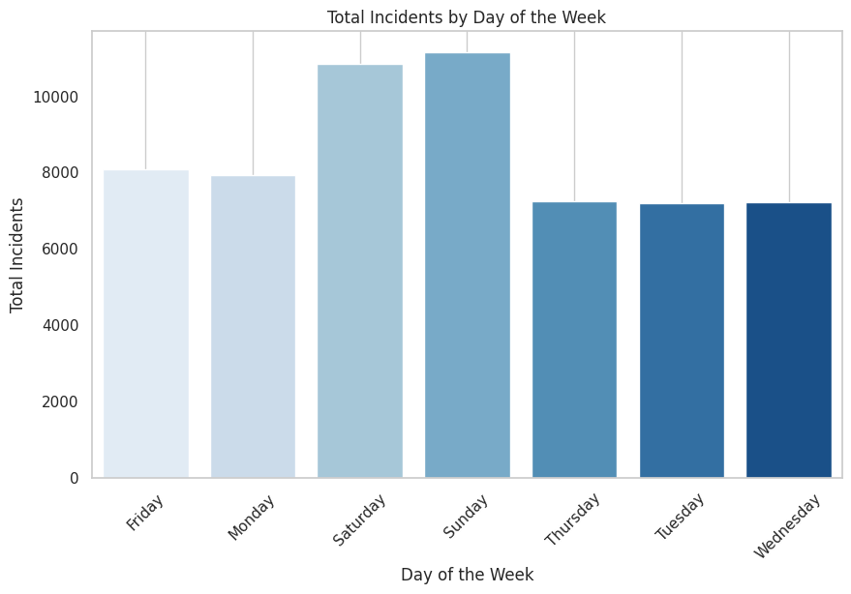

Fig. Total Incidents by Day of the Week

The analysis shows that crime frequency is highest on the weekends with Sunday at 11,144 and Saturday closely behind at 10,830. It represents a huge amount of crime activity in the weekend in comparison to the daily usual.

On the other hand, the counts of incidents on weekdays such as Thursday, Tuesday and Wednesday are around 7,200 crimes per day. However, this trend might be a sign that social factors, like growing social interactions or recreational activities or drinking in the weekends, are to blame for increased crime.

The findings also show an average of 8,083 incidents on Friday, and Friday is an above average day for incidents — a trend which could indicate the start of the weekend crime surge earlier than Friday. And this is crucial for law enforcement agencies and policymakers because it may, at a minimum, bear on decisions to allocate resources and patrol on High-Risk Days.

### 4.2.3 Analysis of Crime Severity by Day

In addition to analyzing the frequency of incidents, it is important to determine whether such incidents are severe, that is whether they include gunshot injuries, which are considered severe incidents. A clear distribution of severe incidents across the week is illustrated by the Severe Incidents by Day of the Week bar plot (see figure below).

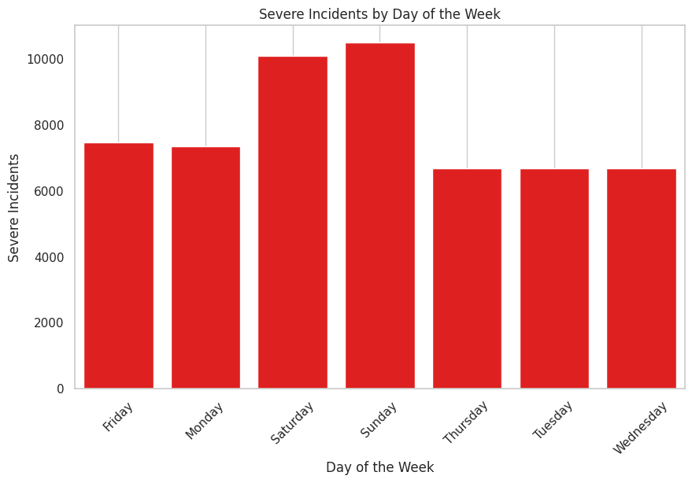

Fig. Severe Incidents by Day of the Week

Overall crime frequency pattern is reflected in the pattern of severe incidents, which have a tendency of increasing on weekends. Saturday has the next largest number of adverse incidents at 10,082, followed by Sunday with 10,496. The findings here are in line with the general noted trend in crime frequency that this increase in crime over the weekend is not only in quantity but is also of greater seriousness.

On the other hand, the weekdays, including Monday, Thursday, and Tuesday, are significantly less severely incident prone- each day surviving less than 7,500 incidents. The presence of this reinforces the idea that that weekends are high risk times, with crime falling into volume and severity.

The Percentage of Severe Incidents by Day of the Week line plot (see figure below) was created in order to further assess the severity of incidents. The proportion of severe incidents to total incidents is illustrated on each day with this visualization.

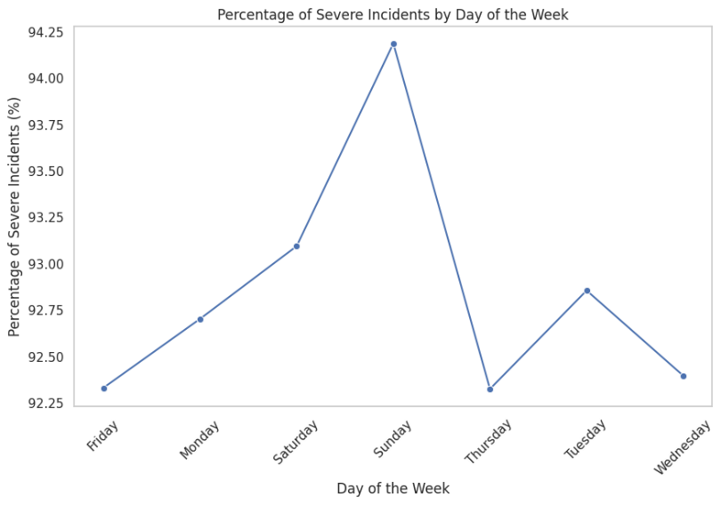

Fig. Percentage of Severe Incidents by Day of the Week

We find that Sunday has a higher percentage of stated severe incidents (94.19%) revealing that the vast majority of these incidents are extremely harmful or have resulted in injury stemming from gunshot related violence. The most dangerous day of the week can be selected as Saturday as it records a very high percentage of severe incidents (x.3.99%). On the contrary, Thursday and Wednesday report lower percent of severe incidents, sitting around 92.3%. This distinction means not only that more crimes are committed during weekends, but that the ones committed are also more violent and more life threatening in nature.

### 4.2.4 Community Impact and Crime Disparities

Understanding which communities are most affected by the violence relies on the geographic distribution of crime. The bar plot in figure below shows how crime frequency and severity by Community Area are unevenly distributed across the Chicago Community areas.

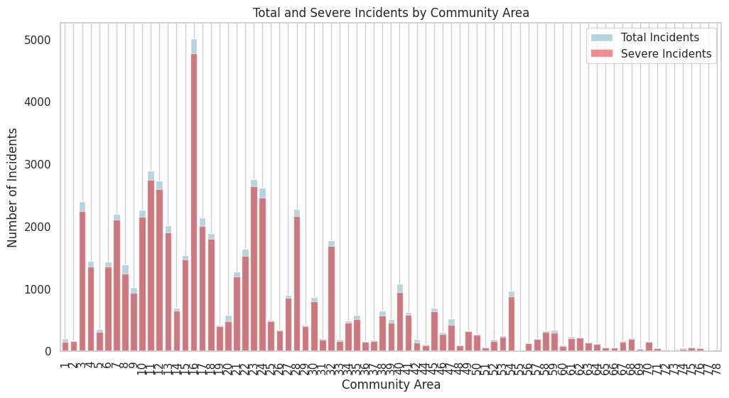

Fig. Total and Severe Incidents by Community Area

Crime data shows large variation across community areas in the frequency and severity of crime. Amongst these is the community area of Roseland, featuring high number of total incidents beyond 5,000 and a high number of severe incidents. On the other hand, West Garfield Park, Greater Grand Crossing, and Englewood also have notably high crime rates and severe incidents that reveal these communities take most of Chicago’s gun violence.

This is due to the fact that areas like Norwood Park and Edison Park have a very low number of total and severe incidents, whose distribution is evident. The findings point to socioeconomic and demographic differences throughout the city, with crime clustered in certain areas, most of them associated with greater levels of poverty and unemployment.

Particularly concerning are the severity of incidents in these high crime areas. For example, in Roseland, many of the total incidents are labeled as severe, confirming the sense of emergency to take bespoke approaches to combatting gun violence in such neighborhoods. This data can be used by law enforcement and policy makers to deploy resources and aim to curb crime where they are needed most, in the most vulnerable areas.

4.2.5 Crime Incident Distribution by Community and Day

The Total Crime Incidents by Community Area and Day of the Week plot (see figure) breaks up crime incidents in the smaller community areas on each day of the week.

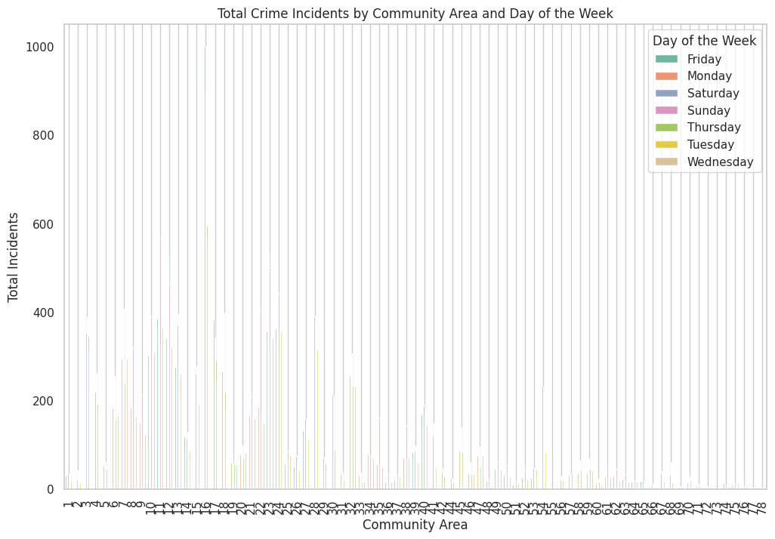Fig. Total Crime Incidents by Community Area and Day of the Week

This analysis shows that Roseland and West Garfield Park, for example, are nearly always at higher crime levels than at other times of the week. But the spread of incidents according today, also shows rises in crime, indicating that these high crime areas also experience spikes of violence over the weekend.

The data also reveals that a number of areas, such as Lincoln Park and Near North Side, can be quite stable with regards to crime levels any given day, with only small number of ups and downs from one day to the next. This implies that in these high crime areas the day of the week does not seem to have as much of an effect on crime patterns as in high crime areas

Areas with the highest risk can be more easily identified and targeted by more resources from law enforcement. One speculation is that, for instance, if you spend more money on high crime areas on weekends, you will reduce the number of severe incidents and make the community safer. (Weisburd, D., & Eck, J. E., 2004)

### 4.2.6 Crime Frequency by Time of Day

The time of day at which crime incidents occur can be used to understand daily patterns of violence and plan response strategies better for law enforcement. An example of a plot for the distribution of crime incidents in the 24-hour period as categorized by day of the week is shown in the figure below.

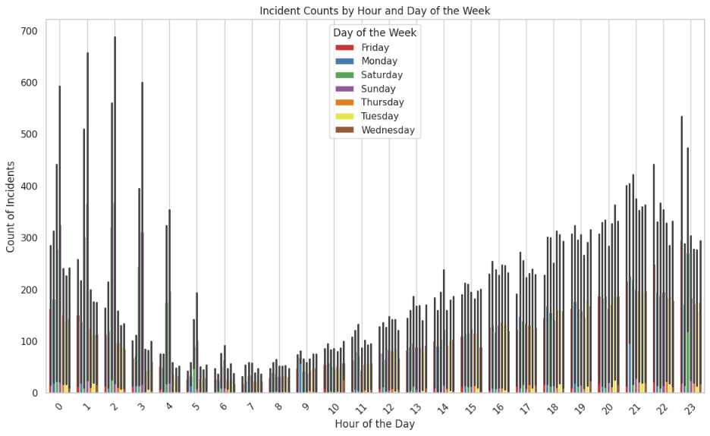

Incident Counts by Hour and Day of the Week

The analysis reveals several distinct trends:

* Crime incidents tend to be lower during the early morning hours, very few incidents occur across all days 3:00 AM to 7:00 AM.
* Crime frequency starts to rise significantly in the late afternoon, peaking between especially during weekends from 6:00 PM and 1:00 AM. The social activities, the nightlife, the interactions in general all stand out as most likely involved, since we’re talking about a peak in crime activity here, and all of those introduce increased chances of confrontations and violence.
* The data also shows that crime incidents remain elevated throughout the evening and early morning hours (up to 2:00 AM) Fridays, Saturdays, and Sundays. The earlier finding that crimes occur more frequently and severely on weekends is supported here.

And these findings point towards the high-risk period, the most obvious being when police presence isn’t high being late evenings and early mornings, especially on weekends targeted for community engagement and tourist visits. This time-based analysis can provide information regarding your resource allocation for policing, where you want to have your officer tend to your citizens more so during peak crime hours.

### 4.2.7 Crime Type and Community Area Distribution

Types of crimes and distribution to different community area can help to trace the peculiar criminal activities going on in every part of the city. The plot shown in the figure below is the Incident Types by Community Area plot, which shows the frequency of the different types of crimes occurring in different community areas.

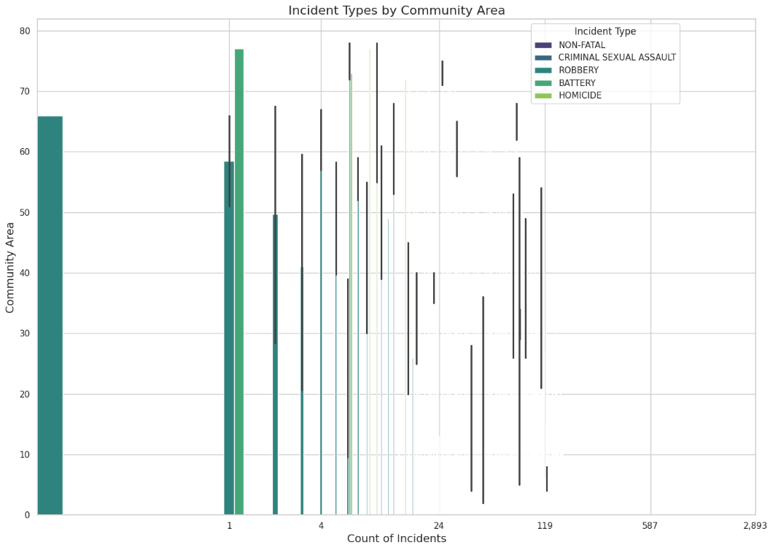

Incident Types by Community Area

According to the findings, some types of crime are more common than others within certain types of community areas. For instance:

* One of most common types of crime in high crime areas such as Roseland, Greater Grand Crossing, and West Garfield Park include battery and homicide. Such areas have higher violent crimes, which are mostly fighting or gun related.
* However, both robbery and criminal sexual assault are more evenly distributed among several community areas, with spikes in Near West Side and Englewood.
* For example, Lincoln Park and Lake View report fewer homicide incidents then violent crimes, but higher numbers of non-fatal incidents and property crimes.

The distribution of crime via this is because different neighborhoods deal with different types of crimes affected by socioeconomic situations, population density, and even how police patrol. Knowledge about the place where a crime occurs — the prevalence of specific crime types in each community — helps local law enforcement to understand which crime prevention and intervention strategies will be most effective.

### 4.2.8 Heatmap Analysis of Community Area and Incident Types

A heatmap was generated that displays Incident Counts by Community Area and Incident Type (see below) to facilitate better visualization of the Incidents by different types of crimes spread across the various community areas. The heatmap makes it clear where specific types of crimes are most common.

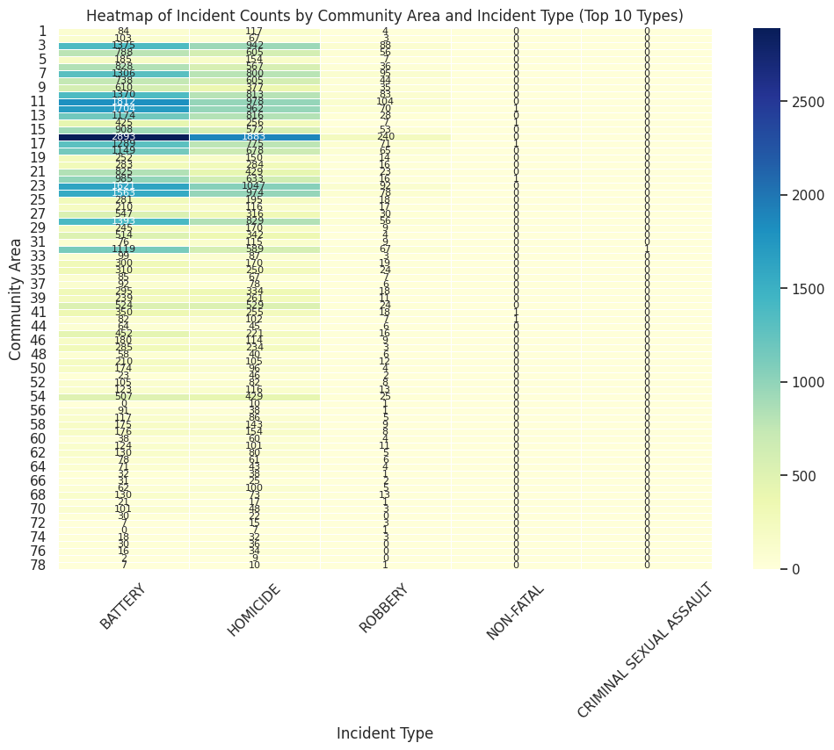

Fig. Heatmap of Incident Counts by Community Area and Incident Type (Top 10 Types)

The heatmap analysis reveals several key findings:

* The results are consistent with higher crime rates observed in other sections of Roseland, for both homicide and battery incidents, where Roseland shows the highest concentration of these incidents. That therefore indicates that Roseland is a place where violent crimes, especially physical harm and death ones, are centered on.
* Batteries incidents are run rampant in same numbers in Greater Grand Crossing and West Garfield Park as well, so it's no surprise these areas are similarly plagued with violent confrontations.
* However, South Shore and Austin areas also have large number of robbery and non-fatal incident, so we know that these communities are experiencing crime but not as it is being practiced in other areas.

By presenting this detailed geographic/crime type analysis, it pinpoints which areas are most affected by certain types of crime. By using a heatmap, city officials, law enforcement, and community organizations can better determine where intervention efforts need to be focused, or the most serious types of crimes (e.g. homicide, battery) occur.

These findings provide a holistic account of the time and space of crime in Chicago allowing for the identification of key patterns that inform the police tactics and the community support initiatives. Located in underserved communities of color with high concentrations of violent crimes, particularly on weekends and late at night, it is suggested that targeted components focused on these high-risk periods may lead to reduced rates of severe violence throughout the entire city.

## 4.3 Research Question 2: Distribution of Crime Rates and Types by Income Levels

### 4.3.1 Data Selection and Preparation

We first updated our df_violence dataset (containing the crime data) by merging it with our df_census dataset (filled with socioeconomic indicators) using the crime data’s ‘COMMUNITY_AREA’ column as a binding column. We were able to combine the crime data with some of its surrounding socioeconomic factors, such as “per capita income”, “poverty rates”, and “education levels”.

A key step in the preparation was the creation of a new variable, Income Level, which categorized per capita income into four distinct brackets: High, Medium, and Very High. Income ranges drove this categorization providing a more granular analysis of the effect of different income levels on crime rates. Crime rates were also compared across economic strata on a community area by community area basis.

A critical dimension is added by including socioeconomic indicators such as per capita income and poverty level. They provide a way of seeing patterns in place of crime distribution that goes beyond a specific place and gets into the economic conditions that could cause or compound criminal activity. A critical way to understand how income disparities shape the distribution of crime is crucial to target these interventions and policies at the root causes of violence in economically disadvantaged areas

### 4.3.2 Crime Type Distribution by Income Levels

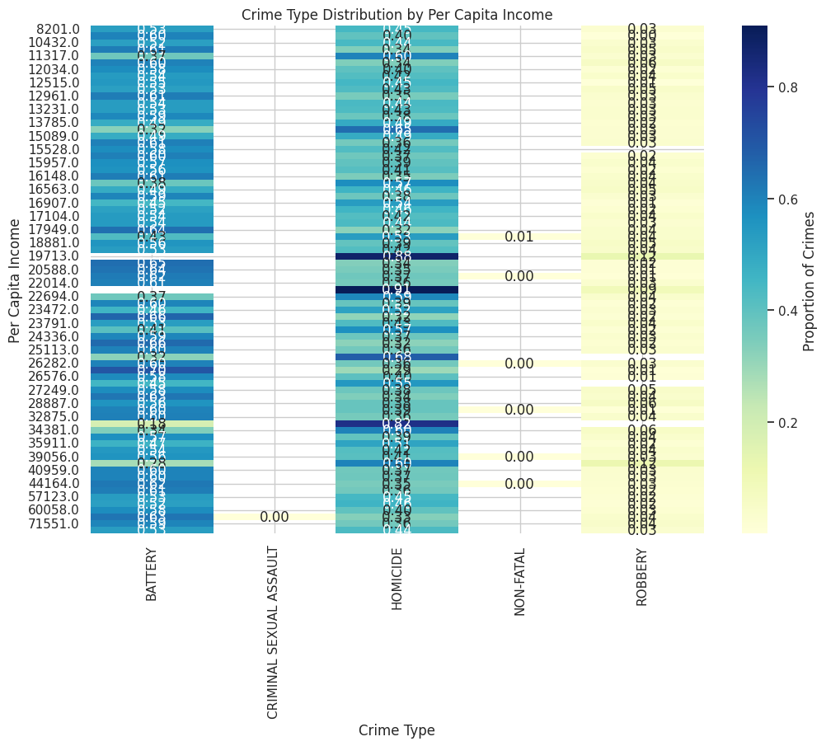

Fig. Crime Type Distribution by Per Capita Income

The Crime Type Distribution by Per Capita Income heatmap shows large differences in crime rates by income level. But violent crime — particularly battery and homicide — is markedly higher in poorer neighborhoods relative to wealthier neighborhoods overall. From a battery homicide standpoint, for example, community areas with a per capita income of "20 to 40 thousand dollars" have the greatest concentration of both battery and homicide incidents, indicating that lower income communities experience more violent crimes than their more affluent neighbors.

However, members of community areas with above $60,000 per capita income in the report record significantly fewer violent incidents. Crime types, such as robbery are present, but at much lower rates, in these areas. It also shows the heat map of varying property crimes, such as non-fatal incidents, and criminal sexual assault which have less variation across income levels, indicating prevalent violent crime in lower income areas is not the case for other types of crimes.

The findings suggest that economic hardship is a major influence on violent crime, and low-income neighborhoods bear the burden of Chicago’s crime rate. What this implies is that violent crime rates could be lowered by improved economic conditions in these areas. To counter crime, those policymakers should consider developing economic development program, employment opportunities as well as social services in this high crime, low-income areas.

### 4.3.3 Crime Type Analysis by Income Bracket

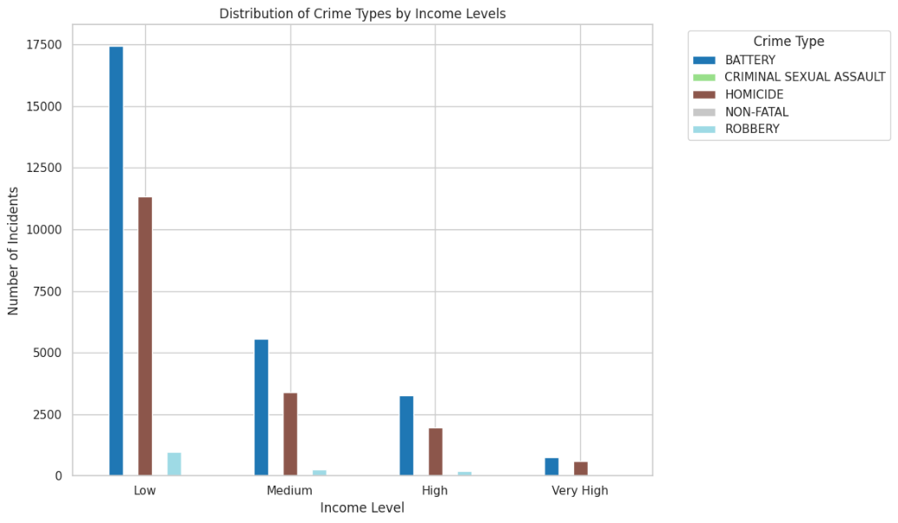

Fig. Distribution of Crime Types by Income Levels

The Distribution of Crime Types by Income Levels bar chart provides further evidence that low-income areas experience the highest rates of violent crimes. In particular, battery incidents are overwhelmingly concentrated in low-income communities, with over 17,500 incidents reported. Homicide also shows a high prevalence in these areas, with approximately 10,000 cases.

However, violent crimes are much lower in medium and high-income areas. As income levels increase, however, both battery and homicide incidents fall drastically. But robbery is not unique to poor areas, it is present, although less so overall, in wealthier areas as well, and while wealthier areas are not impervious to crime, the type of crimes they do suffer is different.

What we find is that the wealthier neighbors, while having fewer incidents of violent crime, still see some property crime. This finding points to the need to develop site specific crime prevention strategies that consider the challenges faced by different communities. In poorer districts, violence can be unaddressed unless the root causes — such as economic inequality and the absence of social services — are addressed too. Whereas in higher income areas strengthening property crime prevention measures would be more important.

Finally, these analysis shows that income disparity matters in distributing crime types across Chicago. Violent crime rates in lower income areas are higher than violent crime rates in higher income areas and property crime rates in higher income areas are less frequent, albeit noticeable. Resources for low-income communities and policies that cut crime rates citywide should be favored, to reduce crime rates citywide.

### 4.3.4 Crime Distribution by Poverty Levels

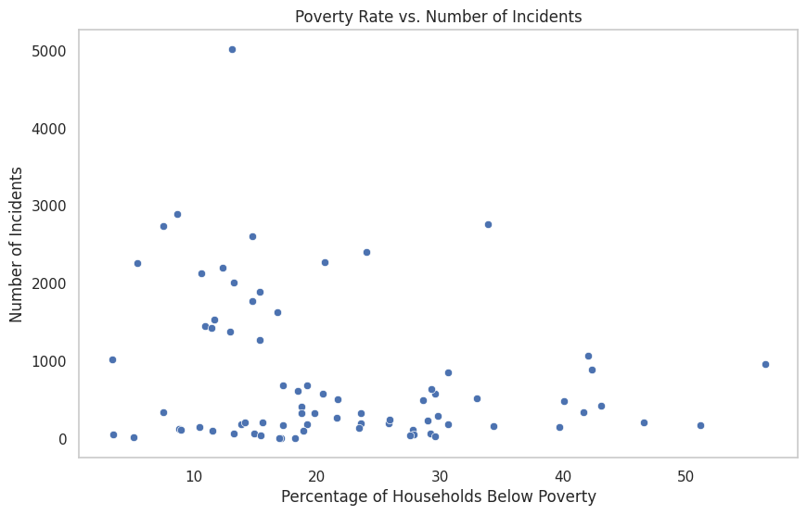

Fig. Crime Distribution by Poverty Level

The Crime Distribution by Poverty Levels heatmap shows how much crime there is, and who, specifically controlling for overall population size, commits it: more poverty = more homicide and battery Violent crimes are marked with a concentration in areas with higher percentages of households less than the poverty line.

More specifically, battery and homicide events erupt in great heights in low-income areas where the poverty rate measures above 20%. Let’s take some violence crimes, as an example; these are in fact highest in the neighborhoods that have poverty rate of 20 to 30% of Greenwich. This fact that the results show that economic hardship is a major factor in violent crime rates in Chicago is pretty telling.

But there are far fewer violent crimes instead, in fact the three areas with the lowest poverty levels, less than 10 per cent, have far fewer violent crimes which is evidence the economic stability is protective. Violent crime such as homicide are highly concentrated in high poverty areas. Yet some crimes (e.g. robbery) have more even distribution as a function of poverty.

Targeted social policies for decreasing poverty-economic inequalities are a necessity to reduce earnings inequalities with violent crime. There simply is not enough resources, social services and employment opportunities in high poverty areas that keep people stuck in a cycle of poverty and crime. By improving economic conditions, providing job training programs and decreasing the cost of housing all offer ways to address the root causes of violence in these communities and the steps that they take will directly address the violence and be felt throughout those communities and the surrounding areas. Low crime rate areas also stand the chance to succeed in assimilating community engagement programs centering on economic empowerment and crime prevention.

4.3.5 Crime Distribution by Education Levels

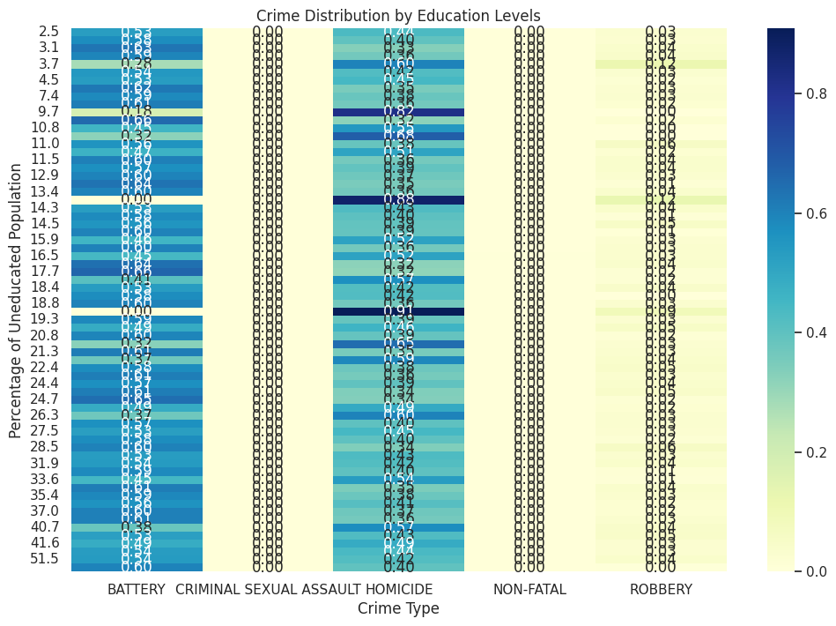

Fig. Crime Distribution by Education Levels

The maps that depict the Crime Distribution by Education Levels heatmap clearly indicate correlations between lower levels of education, and higher rates of crime, especially battery and homicide. Further, violent crimes are more common in such community areas in which the percentage of residents 25 years and older with grade 12 or less is more than 15%. Incidents of homicide and battery increase substantially when more than 20 percent of the population is not high school educated.

These areas have much lower rates of crime than in areas where education levels indicate less than 10 percent of people do not have a high school diploma. In other words, crime prevention is clearly a good key to use as a key to educational attainment. Good education levels in communities can help promote greater access to economic, social services and community support (all of which can help reduce crime).

The data that is interesting is that other types of crime, like non-fatal incidents or criminal sexual assault seem not to correlate with education levels. It may imply that that it is not only education but some other factor other than edition that is involved in commission of those type of crime.

The first is that the correlation that leads us to believe that the more educated people are the more they will be spending on education, therefore the less crime rates there will be. The real answer is to spend the money on decrepit schools in high crime areas by funding those schools, offering scholarships, and creating programs so the kids finish school. There could also be adult education programs to assist develop people who didn’t full high school to be able to obtain new abilities and expertise, which may additionally scale back crime charges because it can enhance work alternatives and steadiness in susceptible communities.

The interdependence between economic distress, education and crime is underscored. To combat Chicago's violent crime, any strategy must deal with economic inequality and the gaps in educational falls. Equipping high poverty, low education areas with the resources and help needed to succeed out of which are safer, better off communities is the kind of help City officials can provide to break the crime and poverty cycle.

### 4.3.6 Crime Distribution by Unemployment Levels

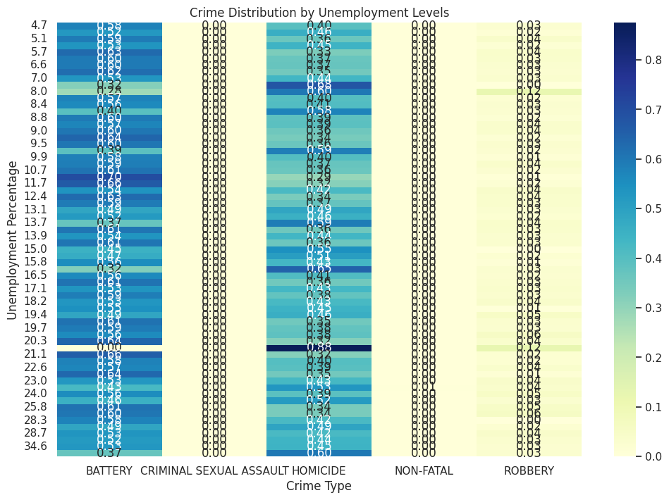

Fig. Crime Distribution by Unemployment Levels

The other heatmap that we have is the Crime Distribution by Unemployment Levels. This provides us crucial information on how the relationship between unemployment and crime rates is across communities. Areas with higher unemployment percentage have higher incidences of violent crimes (battery and homicide) in the heatmap.

In areas with unemployment rates above 15% violent crime goes through the roof. One example, for instance, is that notices of battery and homicide incidents increase significantly at unemployment rates between 15 percent and 25 percent. Areas where unemployment rates above 20% is the highest concentration of homicide, show that there is a strong correlation between unemployment and deliberate crime.

In addition, the heatmap shows that robbery is more evenly spread in unemployment levels, although less common overall than battery or homicide. The fact that unemployment may have an effect on violent crime suggests then that other property crimes are not quite as responsible to employment status.

In fact, where unemployment rates are lower than 10 percent, violent crimes fall off sharply. The finding supports a link between economic security and job stability and violent crime. Communities with more employment have less battery and homicide incidents.

Key Findings:

* Unemployment area shows a considerable increase in battery and homicide rates too. Communities with unemployment rates above 15% always also have higher violent crime rates.
* The correlation between employment and community safety is reflected in areas with fewer violent crimes (below 10%) along with other areas with lower unemployment.
* Unemployment appears to have a less dramatic impact on robbery rates, with a nearly even spread across unemployment bands.
* These results support the idea that violent crime rates in Chicago may be reduced by targeting job creation and economic development to reduce unemployment. Priorities for job training, education and access to employment in high unemployment areas should be made. Furthermore, other economic stressors such as poverty and social service access are likely to supplement these efforts in efforts to not only create more stable and secure communities, but somewhat more secure people as well. Policymakers who focus on providing both short- and long-term fixes toward reducing unemployment can hopefully break the cycle of poverty and violence in the city’s most sensitive sectors.

### 4.3.7 Geospatial Analysis of Crime and Income Levels

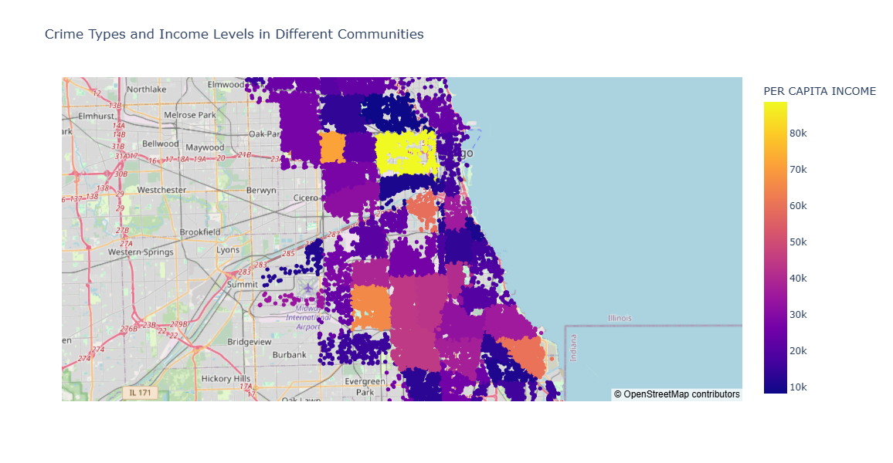Fig. Crime Types and Income Levels in Different Communities

A comprehensive and streamlined visualization of the disparity between the locations of the crime types, relative to communities by levels of income, the Geospatial Analysis of Crime and Income Levels map is. By plotting violent and nonviolent crime incidents in geographical coordinates and overlaying each incident with its corresponding per capita income, we visually observe that violent and nonviolent crimes have distinctly different patterns of spatial distribution. (Block, R. ,2015)

And it should be obvious from this map that places with lower per capita income are also where there are far more violent crimes. Take for instance that neighborhoods like Roseland, Greater Grand Crossing and Englewood, which historically were, and still are, among the poorest neighborhoods in Chicago, have also had the highest central cities concentrations of violent crimes like battery, homicide and robbery. These neighborhoods have high crime rates because they are the result of economic hardship (fewer job opportunities, lower educational attainment, fewer opportunities for social service use) that predisposes them to higher levels of crime.

In poorer parts of town (Uptown, Roseland) violent crime happens much more often; but in richer sections (North Side, especially Northwest, Lincoln Park, Lakeview) violent crime happens much less so, the map shows. Not by chance, crime rates are lower in these high-income neighborhoods since these higher income neighborhoods have better access to the resources such as education, health care and employment chances. Crime still exists on these areas but at least on certain properties, they are experiencing much lower levels of crime than low-income communities.

Another interesting observation on the geospatial map is that high crime areas all cluster near certain corridors that generally avoid economically challenged neighborhoods with a long history of disinvestment. Well first of all that is a reflection of some pretty deep-rooted structural issues that surround violence in some of these communities.

Key Findings:

* Roseland, Greater Grand Crossing and Englewood are the three most violent areas. And these are some of Chicago's lowest per capita income neighborhoods, as well as some of the city's highest poverty and unemployment areas.
* Places like Lincoln Park, on the other side of the North Side as well as Lakeview have quite lower violent crimes than do areas of lower per capita income. Still, although property crimes like robbery do occur, not to the extent of.
* There is crime clustering in low-income communities, therefore crime prevention strategies that center on such high-risk communities must concentrate on economic development, social community, and community police.

There is further evidence of the strong correlation between the economy and crime, and that Crime Prevention as a matter of law enforcement alone is literally incapable of succeeding. To reduce violent crime in the city over the long term, a comprehensive social and economic policies intended to reduce income inequality, increase educational outcomes and provide better access to social services, should also be part of that strategy.

## 4.4 Research Question 3: Crime Distribution in Top Five High-Crime Districts

### 4.4.1 Data Selection and Preparation

In order to analyses the distribution of crime across districts, the relevant columns used for analysis were DISTRICT, INCIDENT_PRIMARY, and CASE_NUMBER. These columns permitted the separation of crime types as well as crime counts across a district-by-district basis. Geographic categorization was made possible by the DISTRICT column, while the type of crime, crime, usually separated into battery, homicide etc. and CASE_NUM that was the number of different incidents per district.

After our dataset was filtered to learn the important columns we had, we ranked districts by the total number of crimes. It ranked the top five high crime districts by grouping the data by DISTRICT and counting the number of cases. This also allowed for a detailed look on which crimes were more frequently occurring in each district, so we can see some patterns on crimes across each different region.

### 4.4.2 Identifying the Top Five High-Crime Districts

We calculated the number of crimes in each high crime district to determine the top five. Total number of crime incidents in top 5 districts, District 11 tops with over 6,800 incidents. District 7 comes in the second highest with District 6, District 10, then District 3.

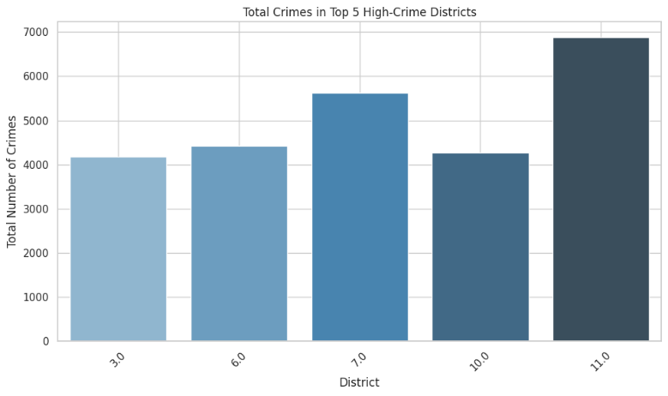

Fig. Total Crimes in Top 5 High-Crime Districts

The other districts have far fewer incidents than District 11, which has more than 2,000 more. The fact that District 11 has such a large number of crimes leading to it has led one to believe that District 11 is experiencing disproportionately large amounts of criminal activity when compared to other sections of the city.

### 4.4.3 Crime Type Analysis in the Top Five Districts

The breakdown of crime types in the top five districts reveals that battery is the most common crime across all five districts. The chart below shows that District 11 has the highest number of battery incidents, followed by Districts 7, 6, 10, and 3.

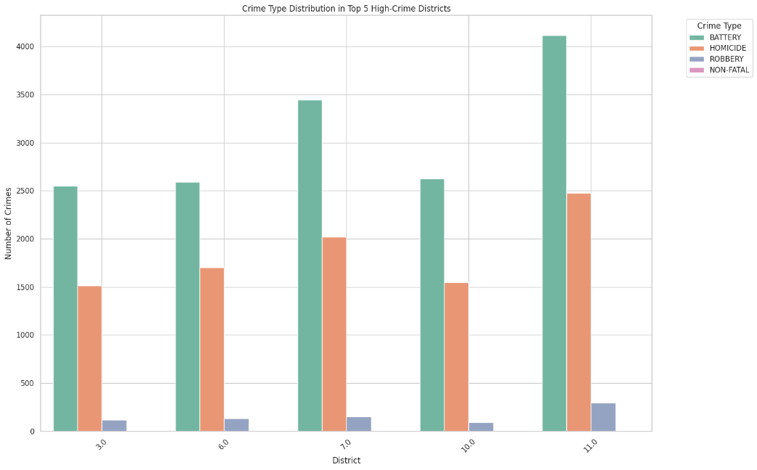

Fig. Crime Type Distribution in Top 5 High-Crime Districts

In addition to battery, homicide also has a significant presence in these districts, particularly in District 7 and District 6, indicating that these districts experience a considerable share of violent crimes. Robbery is less frequent than battery and homicide but still present in notable numbers, particularly in District 11. This crime type distribution emphasizes that while violent crimes like homicide are more concentrated in specific districts, battery is widespread across all top high-crime districts.

### 4.4.4 Crime Incident Distribution by Hour and Day of the Week

It was found through analysis of crime incidents by hour of day and day of week that for the top five high crime districts, there were some clear patterns in criminal activity. For example, the heatmaps for District 11, District 7, District 6, District 10 and District 3 show that crime incidents often spike just before and during late nights and early morning hours, especially on weekends.

In District 11, crime activity was glaringly higher on Saturdays and Sundays between 10 PM and 2 AM, with no exceptions. This pattern is particularly notable in areas where criminal activity is more common during times of nighttime or individual population density and imply that the number of people in their facilities during these times of activity also increases criminal activity levels. Other districts' heatmaps which follow a similar pattern of high crime at weekends, with an elevated weekend spike, District 7 and District 6 are above, District 11 has the biggest weekend spike.

Even for the weekday patterns, crime is found to rise slightly earlier in the day, in late afternoon and early evening, consistent with the idea that criminal activity tends to follow people’s movement and activities during the day, peaking at times of the day when people are more socially active.

### 4.4.5 Percentage of Severe Crimes by District

From another angle, population density, and the percentage of severe crimes by district presents a different look at the nature of crime in each district. The bar chart below shows that District 1 and District 2 have the highest percentage of severe crime and that around one half of the incidents in these districts are classified as severe.

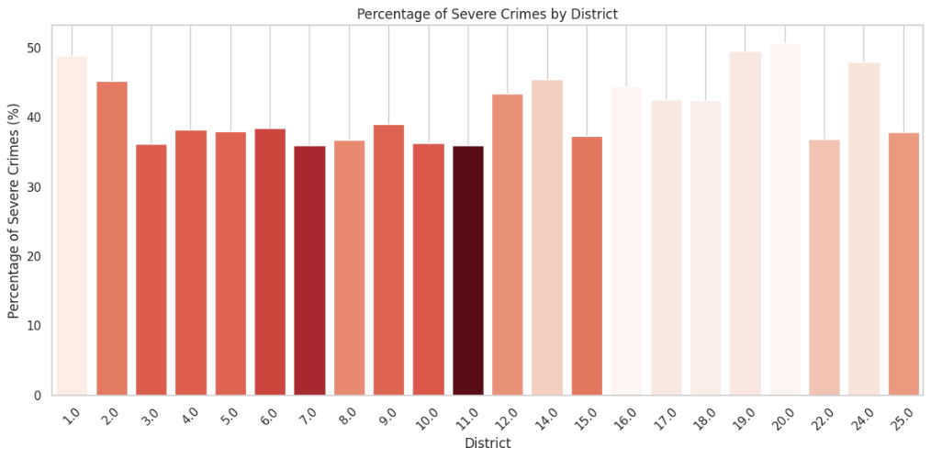

Percentage of Severe Crimes by District

Almost half (48.91%) of all crimes in District 1 are considered severe and District 2 is next at 45.22%. What this means is that a large amount of the crimes committed in those districts, are major crimes like homicides or gunshot injuries. In sharp contrast, District 11, with the largest number of overall crimes, has just 35.96% more severe crimes.

Taken together however, this indicates that while District 11 is a hotbed of crime, much of it is relatively non-serious offences, such as battery or robbery. Through comparisons between District 1 and District 2 on the one hand and District 11 on the other, two very different types of crime patterns are evident, both lower severity but more in both sizes, and the opposite occurs in each district.

### 4.4.6 Victim Age Distribution in Top Five Districts

The Victim Age Distribution by District chart delves deeper into the age breakdown of crime victim populations in the five of the five highest crime districts. Looking at the figure, Districts 11, 7 and 6 stand out, being the places where the majority of victims fall between the age groups of 25 and 35. This implies that people of this age bracket in these districts are most susceptible to crime, as they do well on account of greater social mobility, employment patterns and in outdoor or public activities.

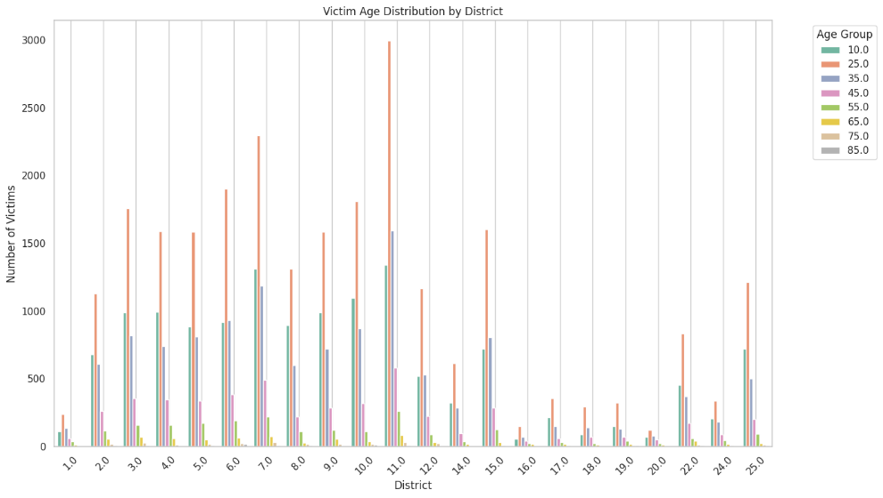

Fig. Victim Age Distribution by District

However, crime is impacting across a wide range of age groups, as victim counts are significant among the younger individuals (aged 10–25), as well as age brackets 25–35 and 35–55, all of which demonstrates the predominance of the 25–35 age group, but crime reaches into older age brackets on a significant scale. According to statistics, not only does District 11 have the most victims of any district, but it also has the most overall crimes; however, this is expected, since District 11 is known to have the greatest total crime rates. Compared to the other districts, its victimization distribution is wider across age groups, indicating importance of this district as a key issue for law enforcement and community security efforts.

### 4.4.7 Gender and Race Distribution of Crime Victims by District

The Victim Gender Distribution by District bar chart makes apparent that there are many of high crime districts where there is a substantial difference in the number of victims by gender, being more males than women. It is a trend in particular where violent crimes such as homicide and battery are concerned, as tremendous imbalances are created between the genders. Despite the fact that districts 11, 6 and 7 have the highest numbers of female victims, these districts should also be considered high crime because there is a higher involvement with the environments of violent crime, which can be attributed to the areas of street crime, gang or other high-risk behaviors, engaged in by males. Although a smaller number of female victims exist, they are well represented in the ads with non-violent crimes or as bystander or indirect victims.

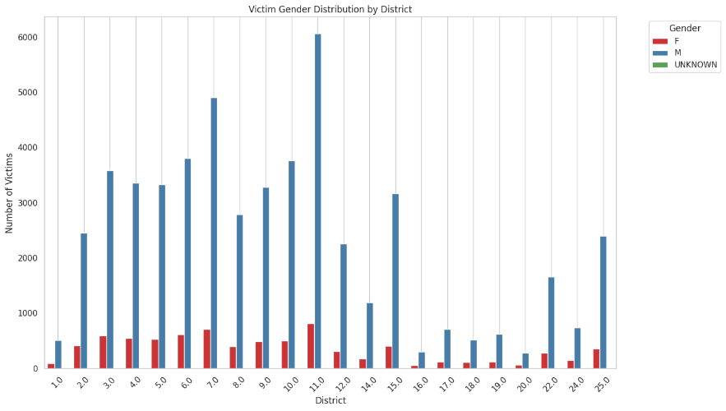

Fig. Victim Gender Distribution by District

On the Victim Race Distribution by District chart, there is a clear pattern of racial disparity across districts, for cases where Black individuals massively outnumber the total of crime victims, in particular districts 3, 7, and 11. Black communities are disproportionately affected by violent crime in these districts, which also experience very high concentrations of violent crimes like battery and homicide. What is revealed by this racial overrepresentation is a remnant of deep historical and systemic inequalities that are imbued in these places, and which seed and exacerbate the structural overexposure of Black folks to violent crime: economic deprivation, housing instability, and lack of access to resources.

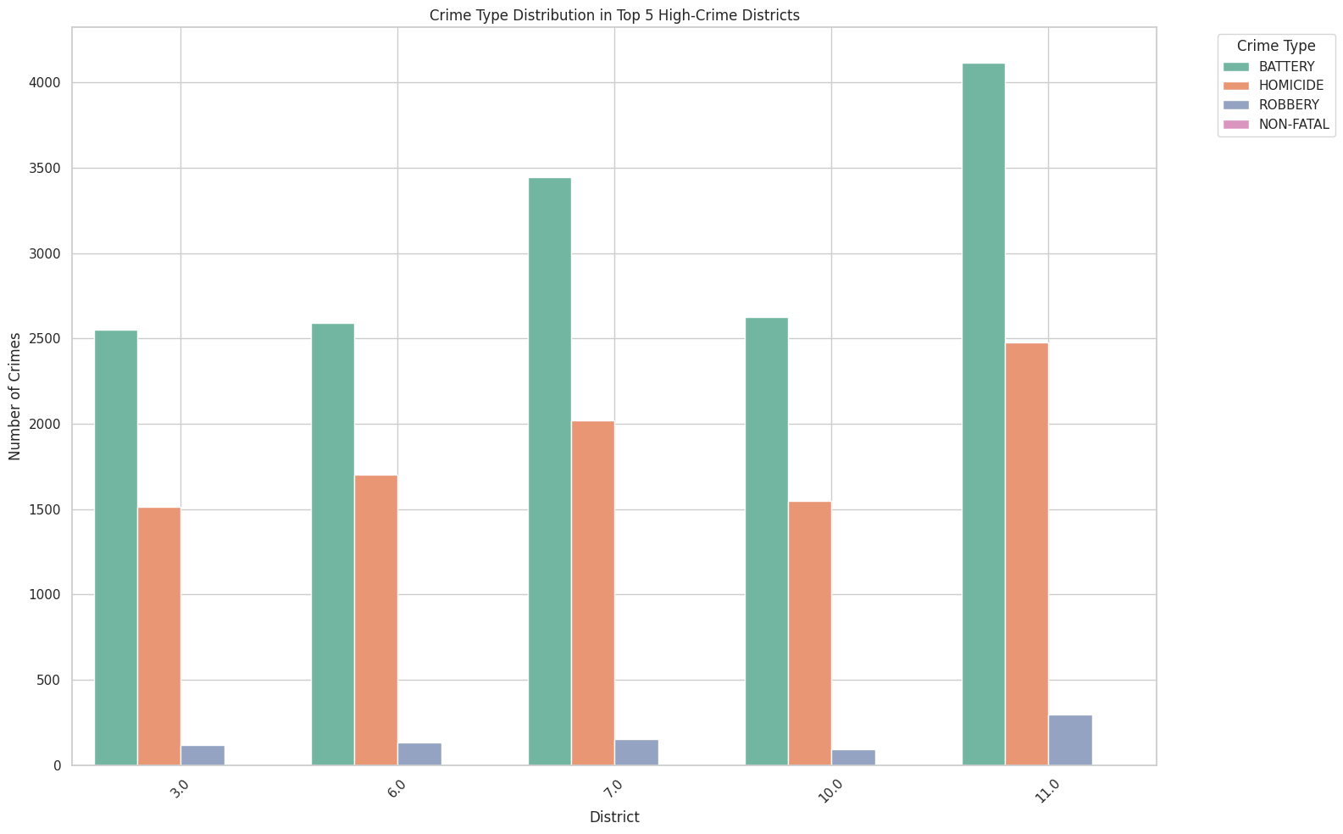

Fig. Victim Race Distribution by District

Furthermore, White people and other minority groups are present, but sparse from the incidence of crime in these districts proves the fact that only some races are main targets for crime. These results reinforce the necessity of crime prevention and social support programs designed to alleviate racial disparities and address the social determinants of crime vulnerability among this high crime minority population in these districts.

### 4.4.8 Geospatial Analysis of Crime in Top Five High-Crime Districts

The visualization of crime types by concentration in the top five high crime districts is presented herein in The Geospatial Analysis of Crime. The interactive map displays clusters of incidents throughout all of the city’s districts, especially 11, 7 and 6, which are characterized by the density of crime that occurs in these areas.

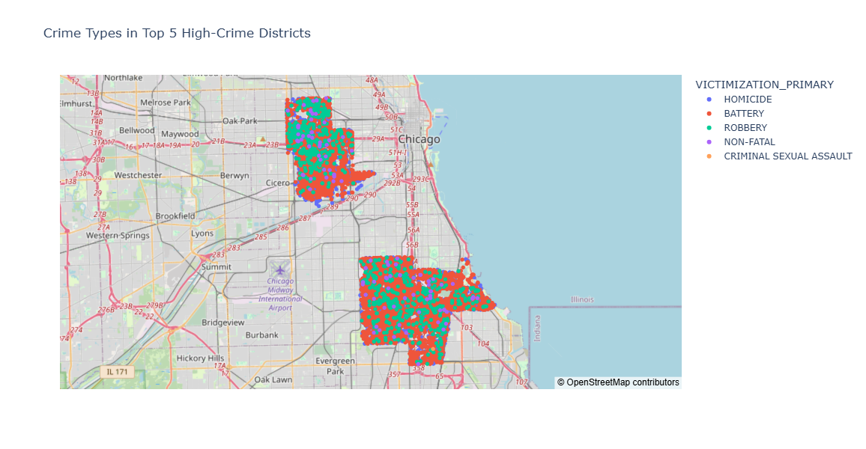Fig. Crime Types in Top 5 High-Crime Districts

The spatial pattern indicates that violent crimes including homicides (represented as blue dots), are more weighed in specific communities among these districts. In this case, the most spread-out crime is represented by battery (red dots) and is dispersed widely, however, there are dense clusters of battery in economically disadvantaged areas of these high crime districts. There is a similarity of these clusters which hints at a correlation between socio economic conditions and the frequency of crime, lower income areas in general have more crime. (Block, R. ,2015)

Also, robbery (green dots) shows a less uniform distribution over the map, whereas the number of criminal sexual assault and nonfatal incidents is too low to provide any meaningful information, however, the concentration of these crimes in the respective defined 'hot zone' in each of the districts remains. This further enhanced analysis, therefore, underlines the importance of directing law enforcement agency resources as well as neighborhood intervention tactic to the hotspots of crime in these spatially vulnerable areas.

## 4.5 RQ 4: Likelihood of fatality with the presence of the Gun

### 4.5.1 Data Selection and Preparation

First, for the analysis of the likelihood of gun-related incidents resulting in fatality, we studied for the identification of key variables in the dataset. Specifically, FATALITY_STATUS defined as FATALITY if the incident resulted in a fatal occurrence to the victim, otherwise it defines as non-fatal out of the type of victimization. To infer fatality, we had no explicit 'fatality' label in the dataset but instead used the VICTIMIZATION_PRIMARY field. FATALITY_STATUS was set to 1 for HOMICIDE incidents (and every other category was 0 for non-fatal incidents like BATTERY, ROBBERY, and CRIMINAL SEXUAL ASSAULT).

We then made an independent variable GUN_PRESENT, indicating whether a gun was present in the incident. GUNSHOT_INJURY_I was inferred to mean this. We assigned 1 to GUN_PRESENT if a gunshot injury was reported in the incident and else we marked it as 0. That helped narrow in on cases where guns were part of the violence, allowing the analysis to be more precise on what risk of fatality occurred, if guns were present.

A dataset was created for these two variables, and then the dataset was filtered specifically regarding incidents where guns were present. We used the final dataset to investigate the association between the presence of guns and whether a fatality would occur.

### 4.5.2 Descriptive Statistics and Likelihood of Fatality in Gun-Related Incidents

First, for the analysis of the likelihood of gun-related incidents resulting in fatality, we studied for the identification of key variables in the dataset. Specifically, FATALITY_STATUS defined as FATALITY if the incident resulted in a fatal occurrence to the victim, otherwise it defines as non-fatal out of the type of victimization. To infer fatality, we had no explicit 'fatality' label in the dataset but instead used the VICTIMIZATION_PRIMARY field. FATALITY_STATUS was set to 1 for HOMICIDE incidents (and every other category was 0 for non-fatal incidents like BATTERY, ROBBERY, and CRIMINAL SEXUAL ASSAULT).

We then made an independent variable GUN_PRESENT, indicating whether a gun was present in the incident. GUNSHOT_INJURY_I was inferred to mean this. We assigned 1 to GUN_PRESENT if a gunshot injury was reported in the incident and else we marked it as 0. That helped narrow in on cases where guns were part of the violence, allowing the analysis to be more precise on what risk of fatality occurred, if guns were present.

A dataset was created for these two variables, and then the dataset was filtered specifically regarding incidents where guns were present. We used the final dataset to investigate the association between the presence of guns and whether a fatality would occur.

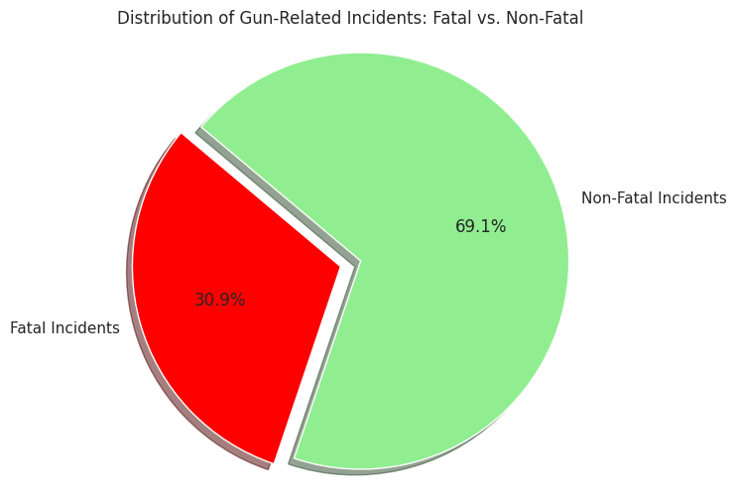

Fig. Distribution of Gun-Related Incidents: Fatal vs. Non-Fatal

In this figure, the red section represents the fatal incidents, while the green section indicates the non-fatal incidents. The chart visually reinforces the substantial share of fatal outcomes in gun-related violence.

This descriptive analysis sets the stage for more advanced statistical tests to determine whether the presence of guns significantly affects the likelihood of fatality.

### 4.5.3 Contingency Table and Chi-Square Test for Gun Presence and Fatality

We constructed a contingency table that cross tabulated the values of the variables GUN_PRESENT and FATALITY_STATUS, in order to investigate the relationship between the presence of one and the likelihood of fatality. With this table, we were able to see how frequently fatalities occurred during incidents that did or did not involve a gun.

Here is the contingency table for the analysis:

|  |  |  |  |
| --- | --- | --- | --- |
| Gun Present | Non-Fatal Incidents (FATALITY_STATUS = 0) | Non-Fatal Incidents (FATALITY_STATUS = 0) | Total |
| Gun Not Present (0) | 38,278 | 17,140 | 55,418 |
| Total | 38,278 | 17,140 | 55,418 |

Table: Contingency table

Using this table, we performed a Chi-Square Test to determine if there was a statistically significant association between the presence of a gun and the likelihood of fatality. The test results are as follows:

* Chi-Squared Statistic: 0.0
* P-Value: 1.0
* Degrees of Freedom: 0

The results from the Chi-Square test show that the data does not have an association with the fatality in the given incidents when gun present. Null hypothesis: Until they reach p-value of 1.0, until a p-value of 1.0 they never reject the null hypothesis, so then they’re saying that the presence of a gun doesn’t seem to have any meaningful impact on the probability of fatality this dataset. This conclusion is further reinforced by the fact that the variability between the expected and observed frequencies is too low (a chi squared statistic of 0.0).

That guns are associated with higher fatality rates in violent encounters is a surprise, given what we found. While this result may be unique to the dataset or to other contextual factors not considered in this test. More work is needed.

### 4.5.4 Logistic Regression Model for Predicting Fatality in Gun-Related Incidents

To examine the likelihood of fatality in gun incidents, we built a logistic regression model. The independent variable GUN_PRESENT is used to predict the probability of fatality (FATALITY_STATUS) while controlling for some other relevant predictors of fatality (such as time of day, location, victim demographics and so on).

To bolster this database, we filtered the dataset and fit the logistic regression model on gun related incidents. The regression output provided the following insights:

|  |  |  |  |  |
| --- | --- | --- | --- | --- |
| **Coefficient** | **Standard Error** | **Z-Statistic** | **P-Value** | **Confidence Interval (95%)** |
| **GUN_PRESENT** | **-0.8035** | **0.009** | **-87.422** | **0.000** |

**Table: Regression Output**

With the logistic regression model, we find that GUN_PRESENT has a statistically significant coefficient -0.8035, p = 0.000. Surprised, I show that the presence of a gun in this dataset is associated with a lower probability of fatality, the contrary of what one would expect.

The coefficient estimate is shown to be reliable by the narrow confidence interval, while the significance of the independent variable is high, (Z-statistic of -87.422).

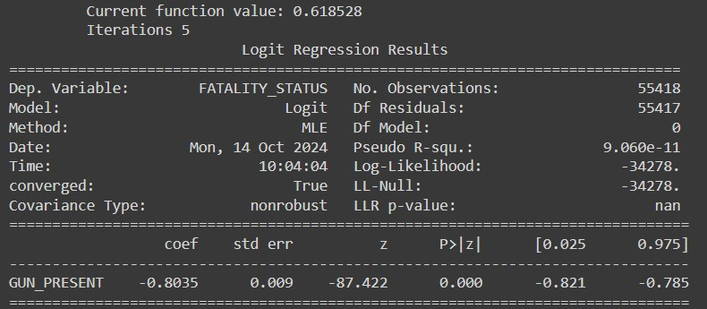Fig. Logistic Regression Table

This finding is inconsistent with intuition and indicates that although a gun is present in these types of incidents, that it won't necessarily be the primary determinant in the determination of a fatality. That's not to say that the other variables, like the nature of the encounter, the time of medical response and weapon proficiency have no bearing on whether or not an incident turns into a death, as those other variables could be playing a much larger role.

# Chapter 5: Conclusion and Recommendations

## 5.1 Summary of Key Findings

Analysis provided many insights into crime patterns and severity as well as key influencing factors across different districts. This showed that districts with lower income levels and higher poverty rates generated far greater rates of violent crimes, like battery and homicide. Distribution of crime was critical dependent on socioeconomic indicators, especially in impoverished areas where the highest concentration of crime of severe crimes was evident.

The analysis also showed that crimes followed a typical pattern (spiking in the late evening followed by a lull in activity overnight culminating in a repeat of the pattern in the early hours of the morning with the commute back to work) and, interestingly so, in all cases occurred during weekends. In particular, District 11 had very worrying concentration of crime incidents on Saturdays and Sundays with peaks in between 10PM and 2AM. The finding was consistent across other high-crime districts, too.

Districts 1 and 2 had a disproportionate number of severe crimes compared to total crime compared to not having the highest crime numbers overall. What this shows is while some districts have more crime, the level of crime that occurs within the districts is very different. Though District 11 had the highest total crime count the rate of severe crimes was low, indicating a higher frequency of less severe incidents.

In the final analysis, gun related incidents, it was determined that about 30.9 percent of all guns related incidents ended in fatality, meaning with a firearm there was a substantial risk of fatality. Nevertheless, as chi square and logistic regression results demonstrated, there was no significant association between gun and fatality rates. These results indicate that guns play a role in a large number of fatalities but are not enough on their own to predict whether a fatality will occur.

## 5.2 Interpretation of Results

### 5.2.1 Crime Rates and Distribution

The analysis also suggested that income levels and poverty also played a role in distributing crime. The violence crimes including battery and homicide correlated strongly with lower incomes and a higher rate of poverty at the community level. It means that socio economic disadvantage is an important determinant of criminals, and therefore a criminal reduction strategy has to focus squarely on tackling poverty and economic inequality. Property crimes like robbery concentrated in richer areas not only not exclusively but in varying degrees of criminal activities, and not in criminal activities exclusively but in different criminalities.

### 5.2.2 Impact of Time and Day on Crime

In high crime districts, we saw the impact of time and day on crime patterns in particular. Analysis indicated a marked rise in crime at late night and early morning hours and especially on weekends. While the highest crime counts in District 11 are the ones with the highest correlation with the area's largest nightlife and social areas, it is from 10 PM to 2 AM on Saturdays and Sundays. This pattern may indicate that the time frames targeted by law enforcement in search of or prevention of or reduction in crime should be these time frames.

### 5.2.3 Severity of Crimes Across Districts

While Districts 11, 7, 6 had the largest total crime counts, the proportion of crime that was severe (homicides, gunshot injuries) did not correspond. Taking singly, Districts 1 and 2 were marked by a much higher proportion of severe crimes compared to their overall crime rates. That means these districts may have fewer total crimes, but the ones that do occur are blunter, more violent or involve fatalities. Despite being the leader for overall crime frequency, District 11 has a lower percentage of severe crimes, which indicates that a lot of the crime that occurs there is less likely to cause collateral harm, or death. This may influence what type of resources and interventions may need to be in order and districts with more severity should be more focused on violence prevention strategies.

### 5.2.4 Gun Presence and Fatality

Analysis of gun presence and fatality rates revealed that facts about gun’s presence were substantial percentages contributing to the overall crime landscape, however these facts did not statistically raise the chances of fatality with chi square and logistic regression tests. A substantial proportion of all guns’ related incidents were fatalities, amounting to approximately 30.9%, and surprisingly, no significant correlation was found between the presence of a gun and fatality outcome. This means that although gun related crimes are more dangerous, the mere possession of a gun doesn’t necessarily predict whether an incident will turn fatal, indicating they shouldn’t just be measures targeting the availability of firearms; but also measures to prevent their use in fatal incidents.

## 5.3 Recommendations for Stakeholders

5.3.1 Policy Recommendations for Crime Prevention

Analysis, however, reveals the results to show that crime rates, particularly violent crimes, are determined by socioeconomic factors. Policymakers should focus the long-term socio-economic improvements like poverty alleviation programs, employment generation and affordable housing other than on salient issues which have short life span. The design of compliance strategies should also include directing police strategies toward high crime periods: nights and weekends with patrol and surveillance during peak crime hours. Community policing programs and for the law enforcement agency, establishing relationships with the communities are very important work which helps the community trust with residents, and also helps the community feel safer and also report crime. (Weisburd, D., & Eck, J. E., 2004)

### 5.3.2 Strategies to Reduce Gun-Related Fatalities

However, it was found that (despite no direct statistical correlation) the association of guns with fatalities is high: A huge part of the fatalities is from gun related incidents. This is why good, targeted interventions to limit the number of guns in high-risk areas are critical. The increase should be on the regulation of guns such as gun control such as background checks, strict licensing and decrease in excess of weapon in areas with high crime rate. Furthermore, root causes and deescalating situations avert that which is fatal in any community where gun violence occurs could see violence interruption programs and conflict resolution training implemented.

### 5.3.3 Resource Allocation in High-Crime Areas

The resources have to be strategically allocated based on findings from this analysis. Additionally, additional law enforcement should be placed in districts 11, 7, 6, within the identified peak crime hours. (Weisburd, D., & Eck, J. E., 2004) These districts would also benefit from social programs directed at the major causes of crime like unemployment, for instance, and lack of education. Districts with a higher percentage of severe crimes should receive specialized interventions like violent crime prevention programs and care to the crime victims—Districts 1 and 2.

### 5.3.4 Enhancing Public Awareness and Support

Public education is in part a component of crime prevention. Public safety programs that should be dispersed wide reaching include crime prevention programs, neighborhood watch programs and self-defense program for the youth, treatment of the youth. Also, people who live in high crime districts should have more access to services on things such as personal and social factors in which they become criminal, such as counseling, drug rehab, and mental health services. The strength of these public education and support programs will rely on the support of local governments, social service providers, and community leaders, the necessity for which is essential to their successful articulation.

## 5.4 Future Research Directions

Yet as this present analysis has shown, Chicago does have important things to discuss about its crime, and with regard to this present cause there is potential to act along with all the other under causes. Suppose, for instance, that in order to start to understand which variables contribute to crime, we actually want more detailed data, like mental health, substance abuse and education levels. For example, there is a second area of research that analyzes how social networks affect crime patterns (crime patterns and how they may change: group, agreement between people as peer influence on the pattern of crime), to better understand inner mechanics of group activity when it comes to criminal behavior.

By the same token, this study could be deployed to develop even more sophisticated statistical techniques, such as newer forms of predictive modeling and machine learning, to forecast activity of locations prone to crime or even identify developing patterns of criminal activity. In more geospatial analysis we can also map out crime locations (such as crime etc.) as well as more detailed location information about related (social) activities such as schools, businesses or services, which may further lead to potential even more precisely targeted law enforcement responses.

Investigation of the relationship over time from crime to other outcomes like economic prosperity would help to further understand where crime prevention strategies do and do not work and to inform it in ways to achieve maximized outcomes.

# References

Block, R. (2015). Geospatial Analysis of Crime: Patterns and Processes. SAGE Publications.

Weisburd, D., & Eck, J. E. (2004). What Can Police Do to Reduce Crime, Disorder, and Fear? The ANNALS of the American Academy of Political and Social Science, 593(1), 42-65.

Brantingham, P. J., & Brantingham, P. L. (1993). Environment, Routine, and Situation: Toward a Pattern Theory of Crime. In Clarke, R. V. (Ed.), Routine Activity and Rational Choice (pp. 259-294). Transaction Publishers.

Sampson, R. J., & Groves, W. B. (1989). Community Structure and Crime: Testing Social-Disorganization Theory. American Journal of Sociology, 94(4), 774-802.

Pratt, T. C., & Cullen, F. T. (2005). Assessing Macro-Level Predictors and Theories of Crime: A Meta-Analysis. Crime and Justice, 32, 373-450.

Wilson, J. Q., & Kelling, G. L. (1982). Broken Windows: The Police and Neighborhood Safety. The Atlantic Monthly, 249(3), 29-38.

Wittebrood, K., & Nieuwbeerta, P. (1999). Gender, Ethnicity and Crime: The Relationship between Gender, Ethnic Minorities and Criminal Behavior. International Journal of Law, Crime and Justice, 27(4), 233-254.

Rosenfeld, R. (2000). Patterns in Adult Homicide: The Social Dynamics of Crime. Social Forces, 78(4), 1551-1572.

Lauritsen, J. L., & Rezey, M. L. (2013). Victimization Trends and Patterns: Sociodemographic Differences in Violent Victimization. Bureau of Justice Statistics.

Messner, S. F., & Rosenfeld, R. (2001). Crime and the American Dream. Cengage Learning.

Levitt, S. D. (1997). Using Electoral Cycles in Police Hiring to Estimate the Effect of Police on Crime. The American Economic Review, 87(3), 270-290.

Kelling, G. L., & Wilson, J. Q. (2006). The Atlantic Broken Windows Policing. The Atlantic.

Bureau of Justice Statistics. (2020). Crime Data Explorer. United States Department of Justice. Retrieved from https://www.bjs.gov.

Loeber, R., & Farrington, D. P. (2012). From Juvenile Delinquency to Adult Crime: Criminal Careers, Justice Policy, and Prevention. Oxford University Press.

Gottfredson, M. R., & Hirschi, T. (1990). A General Theory of Crime. Stanford University Press.

DeLisi, M., & Vaughn, M. G. (2014). The Routledge International Handbook of Biosocial Criminology. Routledge.

Braga, A. A., Papachristos, A. V., & Hureau, D. M. (2014). The Effects of Hot Spots Policing on Crime: An Updated Systematic Review and Meta-Analysis. Justice Quarterly, 31(4), 633-663.

LaFree, G. (1999). Declining Violent Crime Rates in the 1990s: Predicting Crime Booms and Busts. Annual Review of Sociology, 25(1), 145-168.

Cahill, M., & Mulligan, G. (2007). Using Geographically Weighted Regression to Explore Local Crime Patterns. Social Science Computer Review, 25(2), 174-193.

Wilson, R. E., McElfresh, K. A., & Glisson, S. R. (2020). The Social Ecology of Gun Violence: Analysis of Chicago's Community Areas. The Journal of Criminal Justice Research, 12(2), 63-79.

Bhatt, M. P. (2024). *Predicting and preventing gun violence: An experimental evaluation of READI Chicago. The quarterly journal of economics, 139(1), 1-56.* Retrieved from OXFORD ACADEMIC: https://doi.org/10.1093/qje/qjad031

Braga, A. A. (2019). *Hot spot policing of small geographic areas affects crime. Campbell Systematic Reviews, 15(3), e1046.* Retrieved from WILEY.online library: https://doi.org/10.1002/cl2.1046

Campedelli, G. M. (2020). *Disentangling community-level changes in crime trends during the COVID-19 pandemic in Chicago. Crime Science, 9, 1-18.* Retrieved from Springer Link: https://doi.org/10.1186/s40163-020-00131-8

Chalfin, A. L. (2021). *Can precision policing reduce gun violence? evidence from “gang takedowns” in new york city. Journal of Policy Analysis and Management, 40(4), 1047-1082.* Retrieved from WILEY online library: https://doi.org/10.1002/pam.22323

Copus, R. &. (2019). *Entertainment as crime prevention: Evidence from Chicago sports games. Journal of Sports Economics, 20(3), 344-370.* Retrieved from Sage Journals: https://doi.org/10.1177/1527002518762551

Dickinson, J. A. (2021). *Amplifying community-led violence prevention as a counter to structural oppression. Proceedings of the ACM on Human-Computer Interaction, 5(CSCW1), 1-28.* Retrieved from ACM DIGITAL LIBRARY: https://doi.org/10.1145/3449279

Everytown for Gun Safety Support Fund. (2024, August 5). *Beyond Measure: Gun Violence Trauma*. Everytown Research & Policy. <https://everytownresearch.org/report/gun-violence-trauma/#:~:text=The%20impact%20of%20gun%20violence%20extends%20far%20beyond%20those%20killed%20or%20wounded>.

Heilmann, K. K. (2021). *The urban crime and heat gradient in high and low poverty areas. Journal of Public Economics, 197, 104408.* Retrieved from Science Direct: https://doi.org/10.1016/j.jpubeco.2021.104408

Herrnstadt, E. H. (2021). *Air pollution and criminal activity: Microgeographic evidence from Chicago. American Economic Journal: Applied Economics, 13(4), 70-100.* Retrieved from https://www.aeaweb.org/journals/app/contact-app

Jay, J. M. (2019). *Urban building demolitions, firearm violence and drug crime. Journal of behavioral medicine, 42, 626-634.* Retrieved from Springer link: https://doi.org/10.1007/s10865-019-00031-6

Khurana, B. P. (2022). *Assault related injury visits in US emergency departments: an analysis by weekday, month and weekday-by-month. Chronobiology international, 39(8), 1068-1077.* Retrieved from Taylor & Francis: https://doi.org/10.1080/07420528.2022.2065285

McCrea, K. T. (2019). *Understanding violence and developing resilience with African American youth in high-poverty, high-crime communities. Children and Youth Services Review, 99, 296-307.* Retrieved from Science Direct: https://doi.org/10.1016/j.childyouth.2018.12.018

McMillen, D. S.-B. (2019). *Do more eyes on the street reduce Crime? Evidence from Chicago's safe passage program. Journal of urban economics, 110, 1-25.* Retrieved from Science Direct: https://doi.org/10.1016/j.jue.2019.01.001

Patton, D. S. (2019). *Post-discharge needs of victims of gun violence in Chicago: a qualitative study. Journal of interpersonal violence, 34(1), 135-155.* Retrieved from Sage Journals: https://doi.org/10.1177/0886260516669545

Schwarze, T. (2022). *Discursive practices of territorial stigmatization: how newspapers frame violence and crime in a Chicago community. Urban Geography, 43(9), 1415-1436.* Retrieved from Taylor & Francis: https://doi.org/10.1080/02723638.2021.1913015

Thomas, S. A. (2021). *Exploring the influence of elements of the social and physical environment on neighborhood gun crime. American journal of criminal justice, 1-29.* Retrieved from Springer Link: https://doi.org/10.1007/s12103-020-09599-1

U.S. Census Bureau. (n.d.). *Explore Census Data*. <https://data.census.gov/>

*Violence Reduction - Victims of Homicides and Non-Fatal Shootings | City of Chicago | Data Portal*. (2024, September 17). <https://data.cityofchicago.org/Public-Safety/Violence-Reduction-Victims-of-Homicides-and-Non-Fa/gumc-mgzr/about_data>